Parametric Path

Definition
# Source: AI Source: Provided by: [Data Path: Persons Table -> ID Column: 1, Name_En Column: Motasem Essam] -> From: [ChatGPT] on [7/25/2026]
A Parametric Path is a geometric path described by one or more equations in terms of a common parameter, usually $t$. Instead of expressing one coordinate directly as a function of another, the position of a moving point is described as the parameter changes.
For a two-dimensional path:
$$\boxed{x=x\left(t\right), y=y\left(t\right)}$$
or equivalently,
$$\boxed{r\left(t\right)=\left\langle x , \left(t\right)y\left(t\right)\right\rangle }$$
For a three-dimensional path:
$$\boxed{x=x\left(t\right), y=y\left(t\right), z=z\left(t\right)}$$
Simple Definition
A Parametric Path is a path whose position is determined by a parameter that changes as the point moves along the path.
The parameter $t$does not have to represent time. It can simply be a mathematical variable used to trace the path.

Main Classification
# Source: AI Source: Provided by: [Data Path: Persons Table -> ID Column: 1, Name_En Column: Motasem Essam] -> From: [ChatGPT] on [7/25/2026]
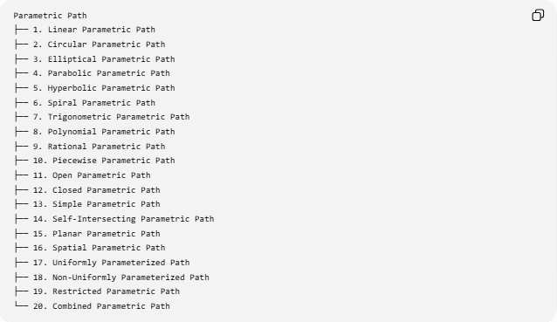
Parametric Path
├── 1. Linear Parametric Path
├── 2. Circular Parametric Path
├── 3. Elliptical Parametric Path
├── 4. Parabolic Parametric Path
├── 5. Hyperbolic Parametric Path
├── 6. Spiral Parametric Path
├── 7. Trigonometric Parametric Path
├── 8. Polynomial Parametric Path
├── 9. Rational Parametric Path
├── 10. Piecewise Parametric Path
├── 11. Open Parametric Path
├── 12. Closed Parametric Path
├── 13. Simple Parametric Path
├── 14. Self-Intersecting Parametric Path
├── 15. Planar Parametric Path
├── 16. Spatial Parametric Path
├── 17. Uniformly Parameterized Path
├── 18. Non-Uniformly Parameterized Path
├── 19. Restricted Parametric Path
└── 20. Combined Parametric Path

1. Linear Parametric Path
# Source: AI Source: Provided by: [Data Path: Persons Table -> ID Column: 1, Name_En Column: Motasem Essam] -> From: [ChatGPT] on [7/25/2026]
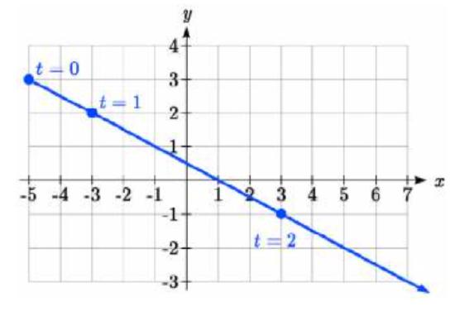
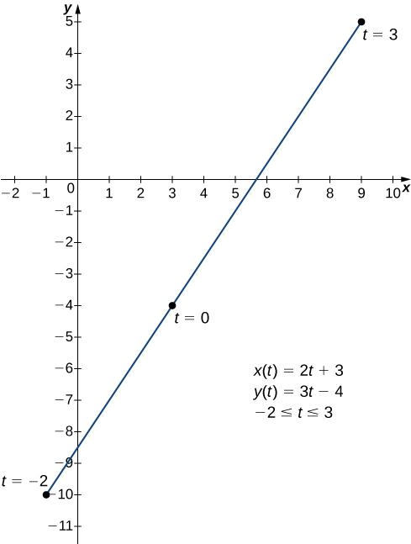
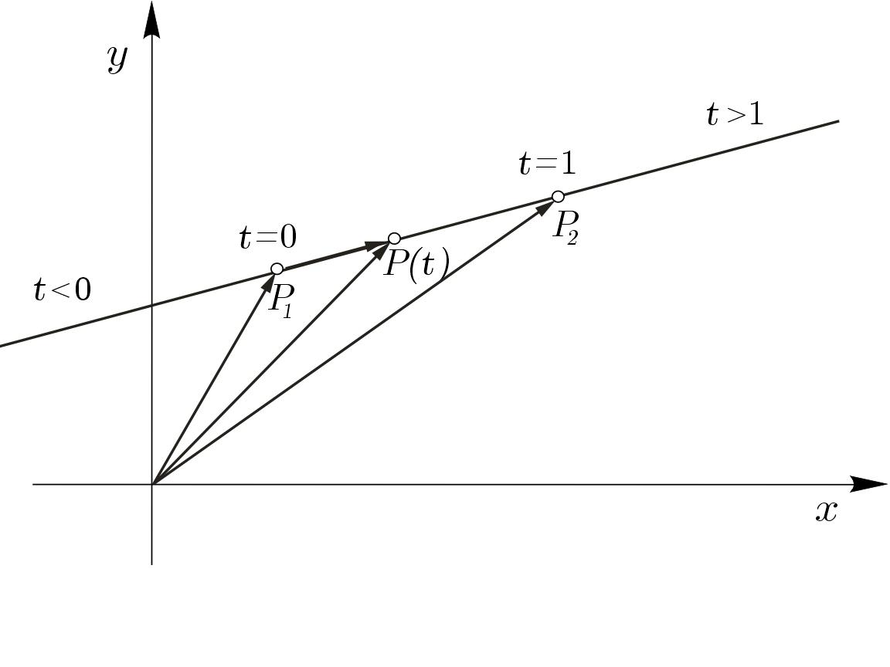
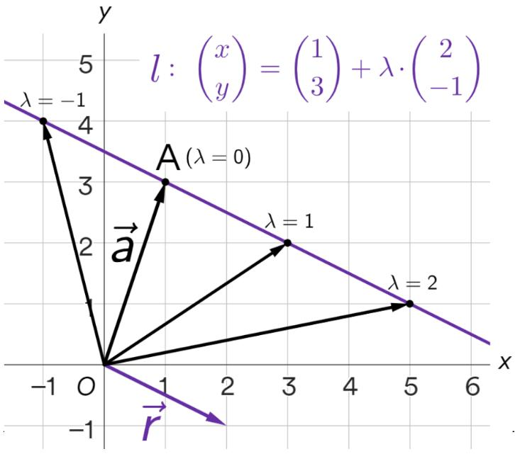
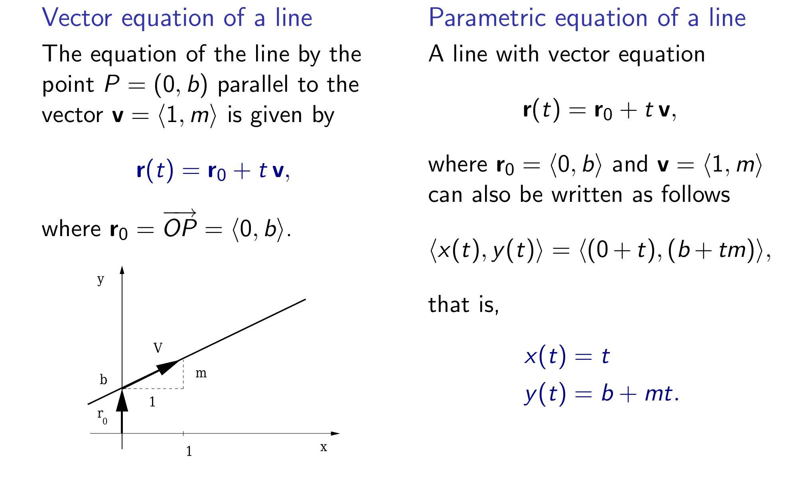
A Linear Parametric Path describes a straight-line path using a parameter.
The standard vector form is:
$$\boxed{r\left(t\right)=A+t\left(B-A\right)}$$
For two dimensions:
$$\boxed{x=x_{0}+at, y=y_{0}+bt}$$
Example
Starting at
$$A=\left(1 , 2\right)$$
with direction vector
$$\vec{v}=\left(3 , 2\right),$$
the path is
$$x=1+3t \\ y=2+2t.$$
This traces a straight line.
Important Point
The parameter changes the position, but the path itself remains linear.

2. Circular Parametric Path
# Source: AI Source: Provided by: [Data Path: Persons Table -> ID Column: 1, Name_En Column: Motasem Essam] -> From: [ChatGPT] on [7/25/2026]
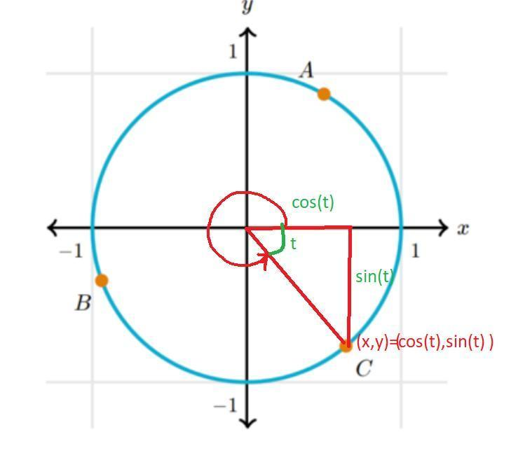
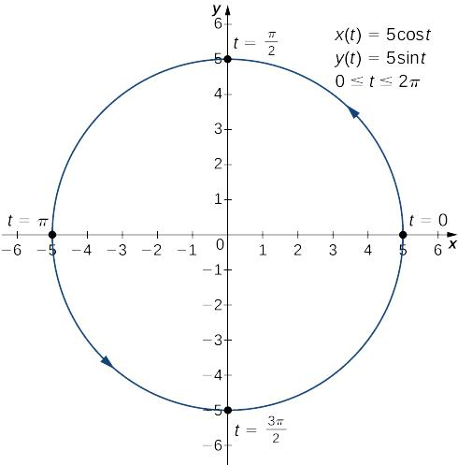
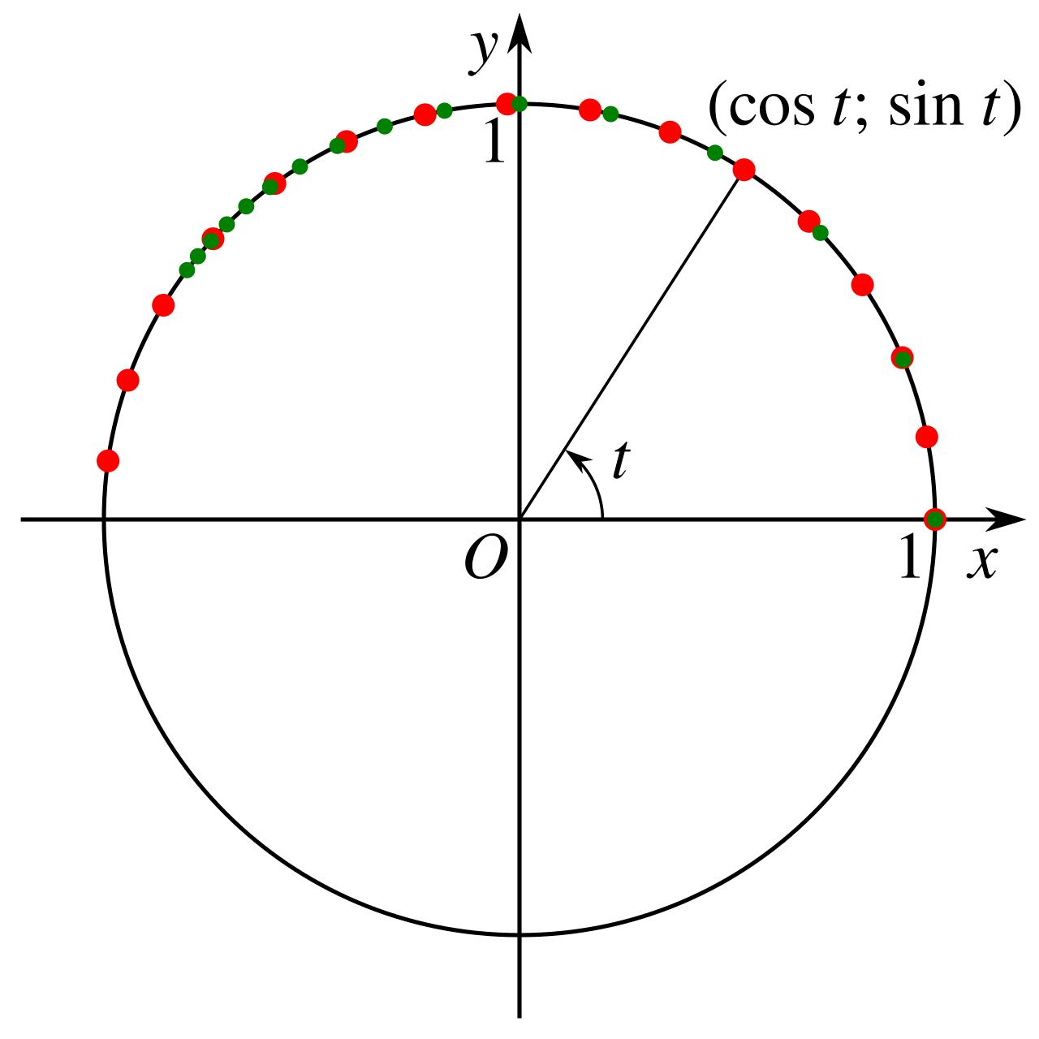
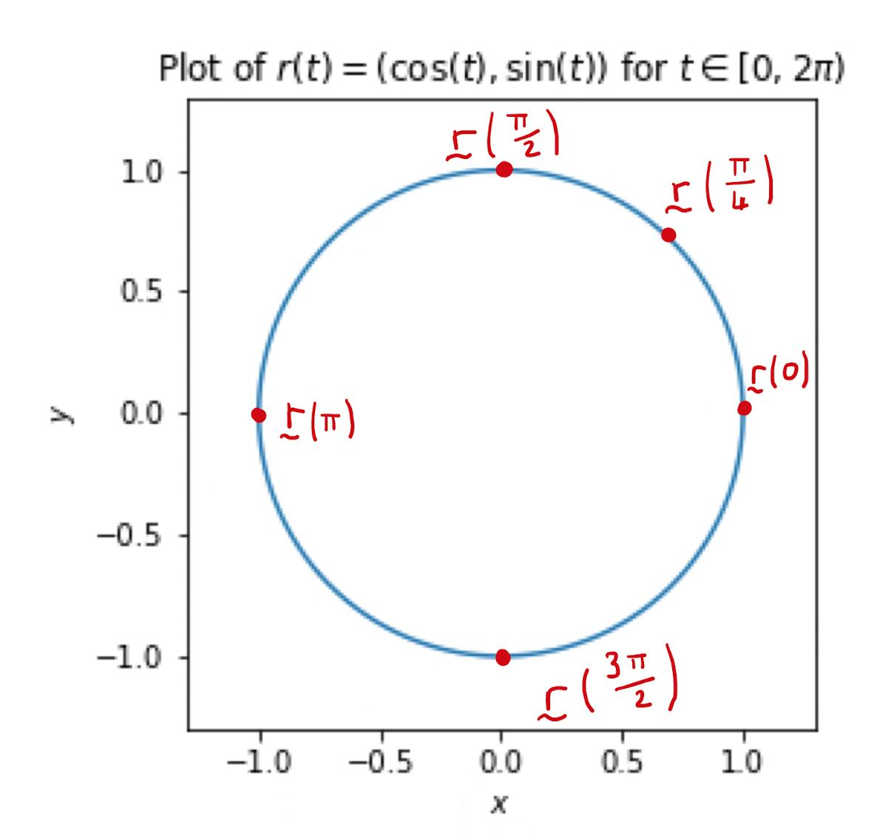
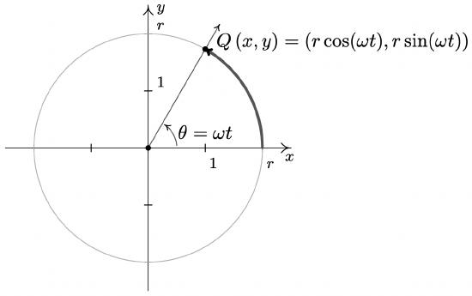
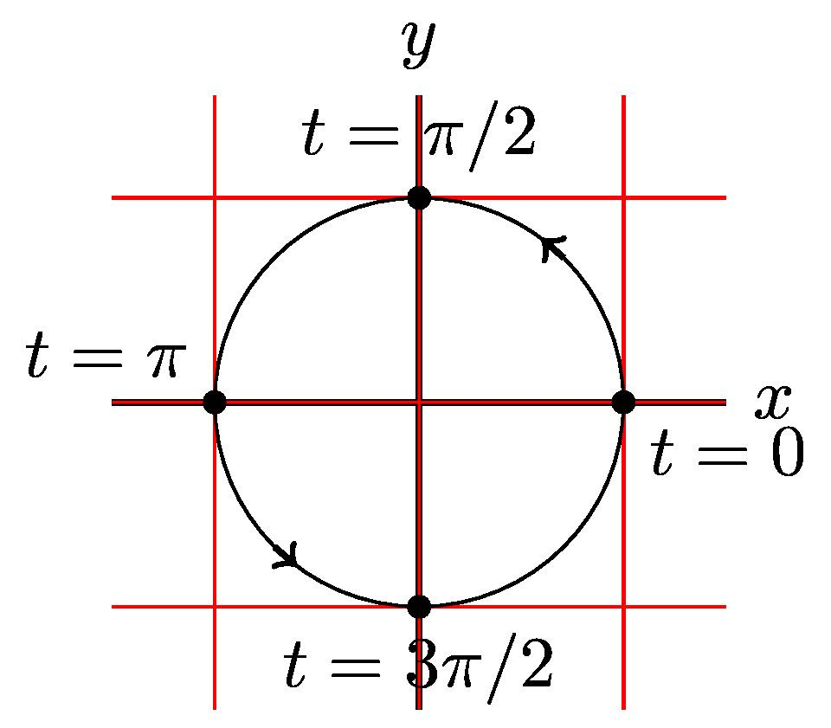
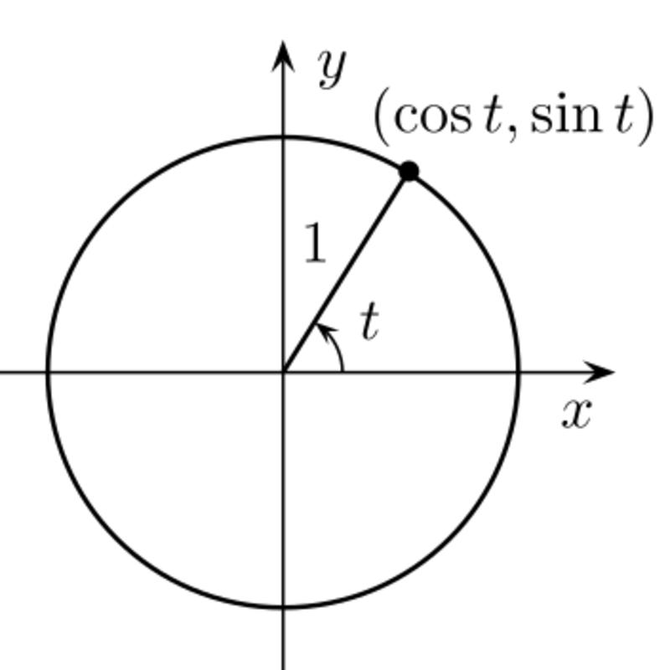
A Circular Parametric Path represents a circle using trigonometric functions.
For a circle centered at the origin:
$$\boxed{x=r\cos{t}, y=r\sin{t}}$$
For center $\left(h , k\right)$:
$$\boxed{x=h+r\cos{t}, y=k+r\sin{t}}$$
where
$$0≤t≤2π$$
traces one complete circle.
Example
For $r=5$:
$$x=5\cos{t}, y=5\sin{t}.$$
Every point satisfies
$$x^{2}+y^{2}=25.$$

3. Elliptical Parametric Path
# Source: AI Source: Provided by: [Data Path: Persons Table -> ID Column: 1, Name_En Column: Motasem Essam] -> From: [ChatGPT] on [7/25/2026]
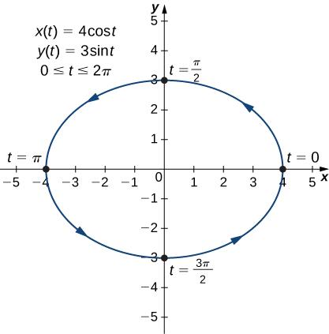
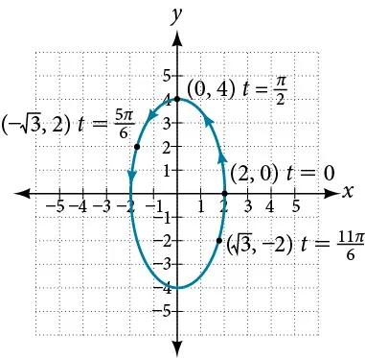
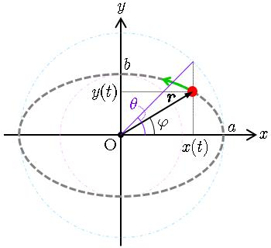
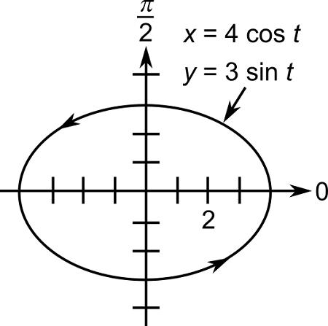
An Elliptical Parametric Path describes an ellipse parametrically.
$$\boxed{x=a\cos{t}, y=b\sin{t}}$$
For center $\left(h , k\right)$:
$$\boxed{x=h+a\cos{t}, y=k+b\sin{t}}$$
Example
$$x=4\cos{t}, y=2\sin{t}.$$
This produces
$$\frac{x^{2}}{16}+\frac{y^{2}}{4}=1.$$
Important Point
A circle is the special case
$$a=b.$$

4. Parabolic Parametric Path
# Source: AI Source: Provided by: [Data Path: Persons Table -> ID Column: 1, Name_En Column: Motasem Essam] -> From: [ChatGPT] on [7/25/2026]
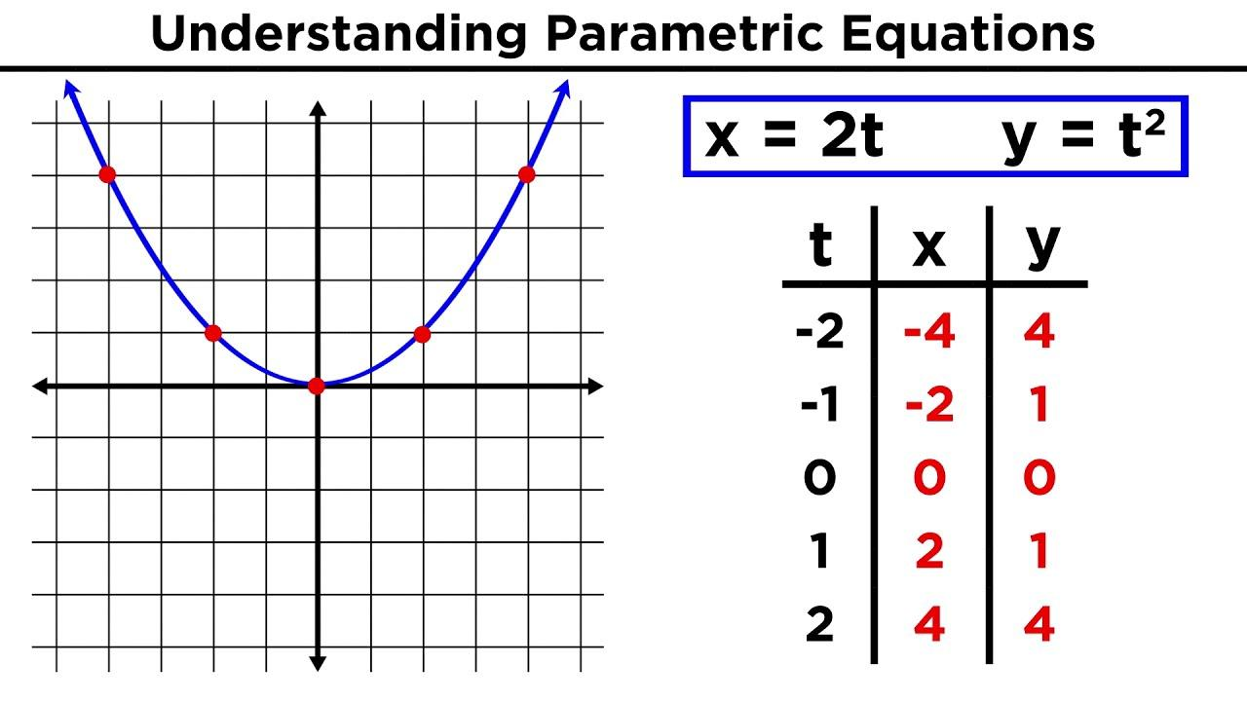
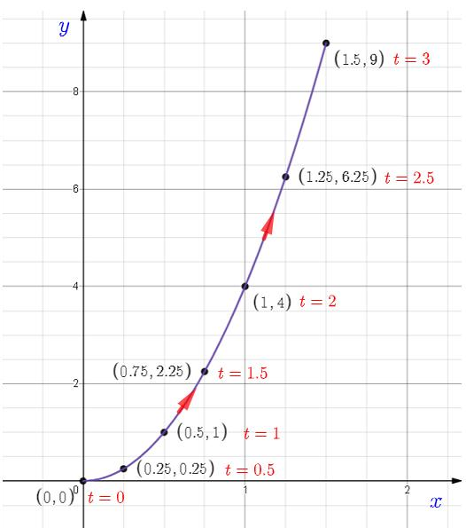
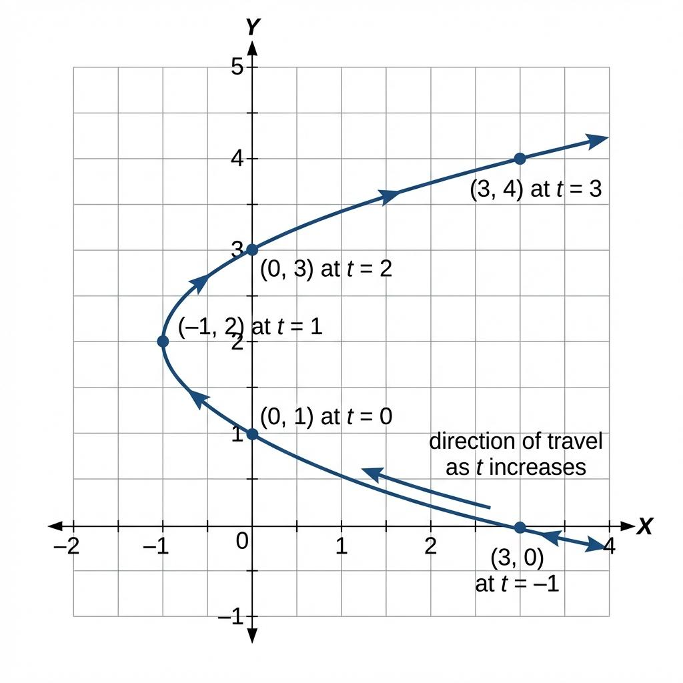
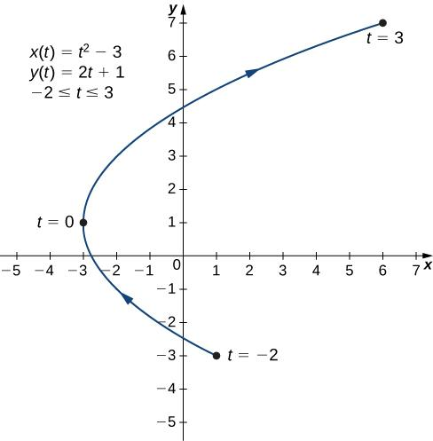
A Parabolic Parametric Path describes a parabola using a parameter.
A simple example is:
$$\boxed{x=t, y=t^{2}}$$
Eliminating $t$:
$$y=x^{2}.$$
Another Form
For
$$y^{2}=4ax,$$
a parametric representation is
$$\boxed{x=at^{2}, y=2at}.$$
Example
For $a=2$:
$$x=2t^{2}, y=4t.$$

5. Hyperbolic Parametric Path
# Source: AI Source: Provided by: [Data Path: Persons Table -> ID Column: 1, Name_En Column: Motasem Essam] -> From: [ChatGPT] on [7/25/2026]
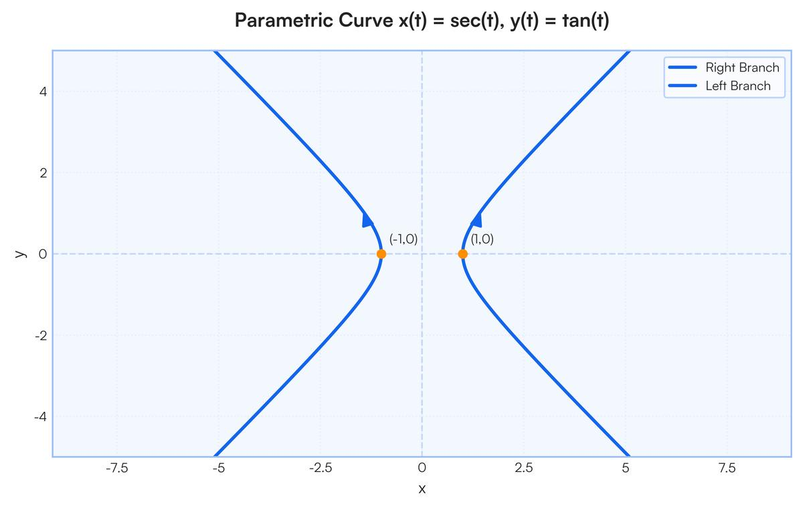
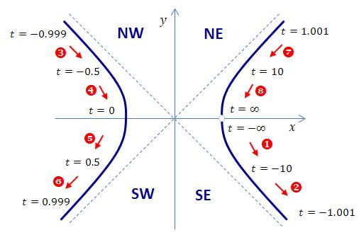
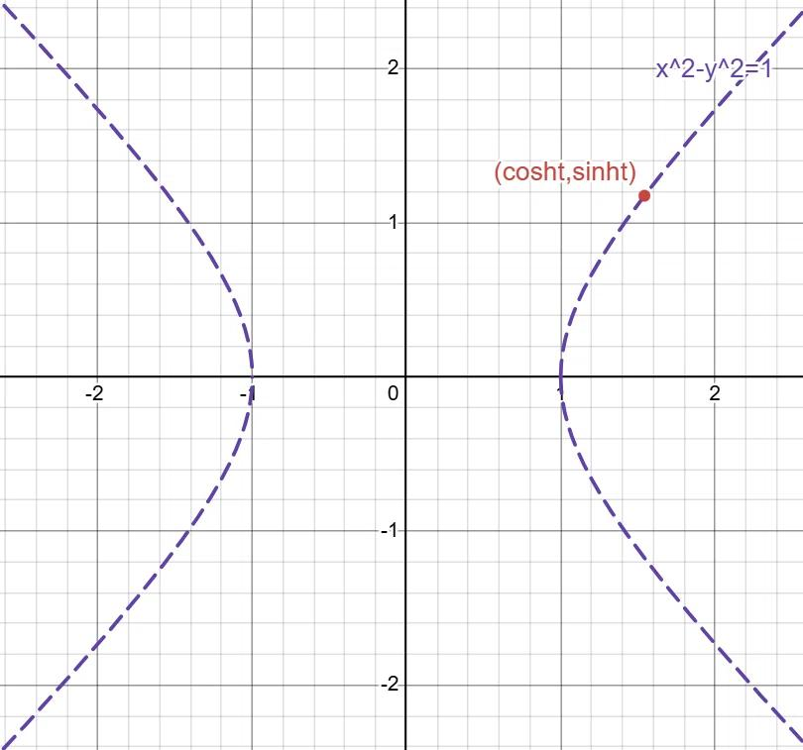
A Hyperbolic Parametric Path represents a hyperbola using a parameter.
For
$$\frac{x^{2}}{a^{2}}-\frac{y^{2}}{b^{2}}=1,$$
one representation is
$$\boxed{x=a\sec{t}, y=b\tan{t}}.$$
Using the identity
$$\sec^{2}t-\tan^{2}t=1,$$
we obtain the hyperbola equation.
Example
$$x=3\sec{t}, y=2\tan{t}.$$
Then
$$\frac{x^{2}}{9}-\frac{y^{2}}{4}=1.$$

6. Spiral Parametric Path
# Source: AI Source: Provided by: [Data Path: Persons Table -> ID Column: 1, Name_En Column: Motasem Essam] -> From: [ChatGPT] on [7/25/2026]
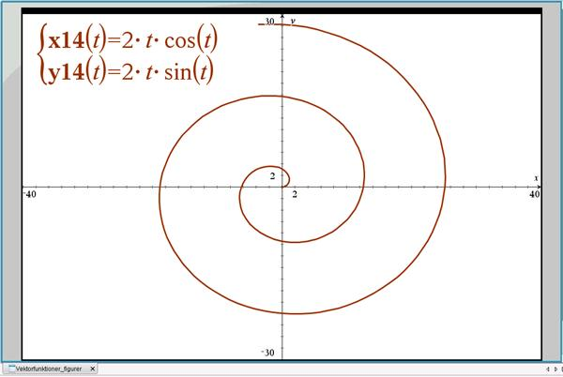
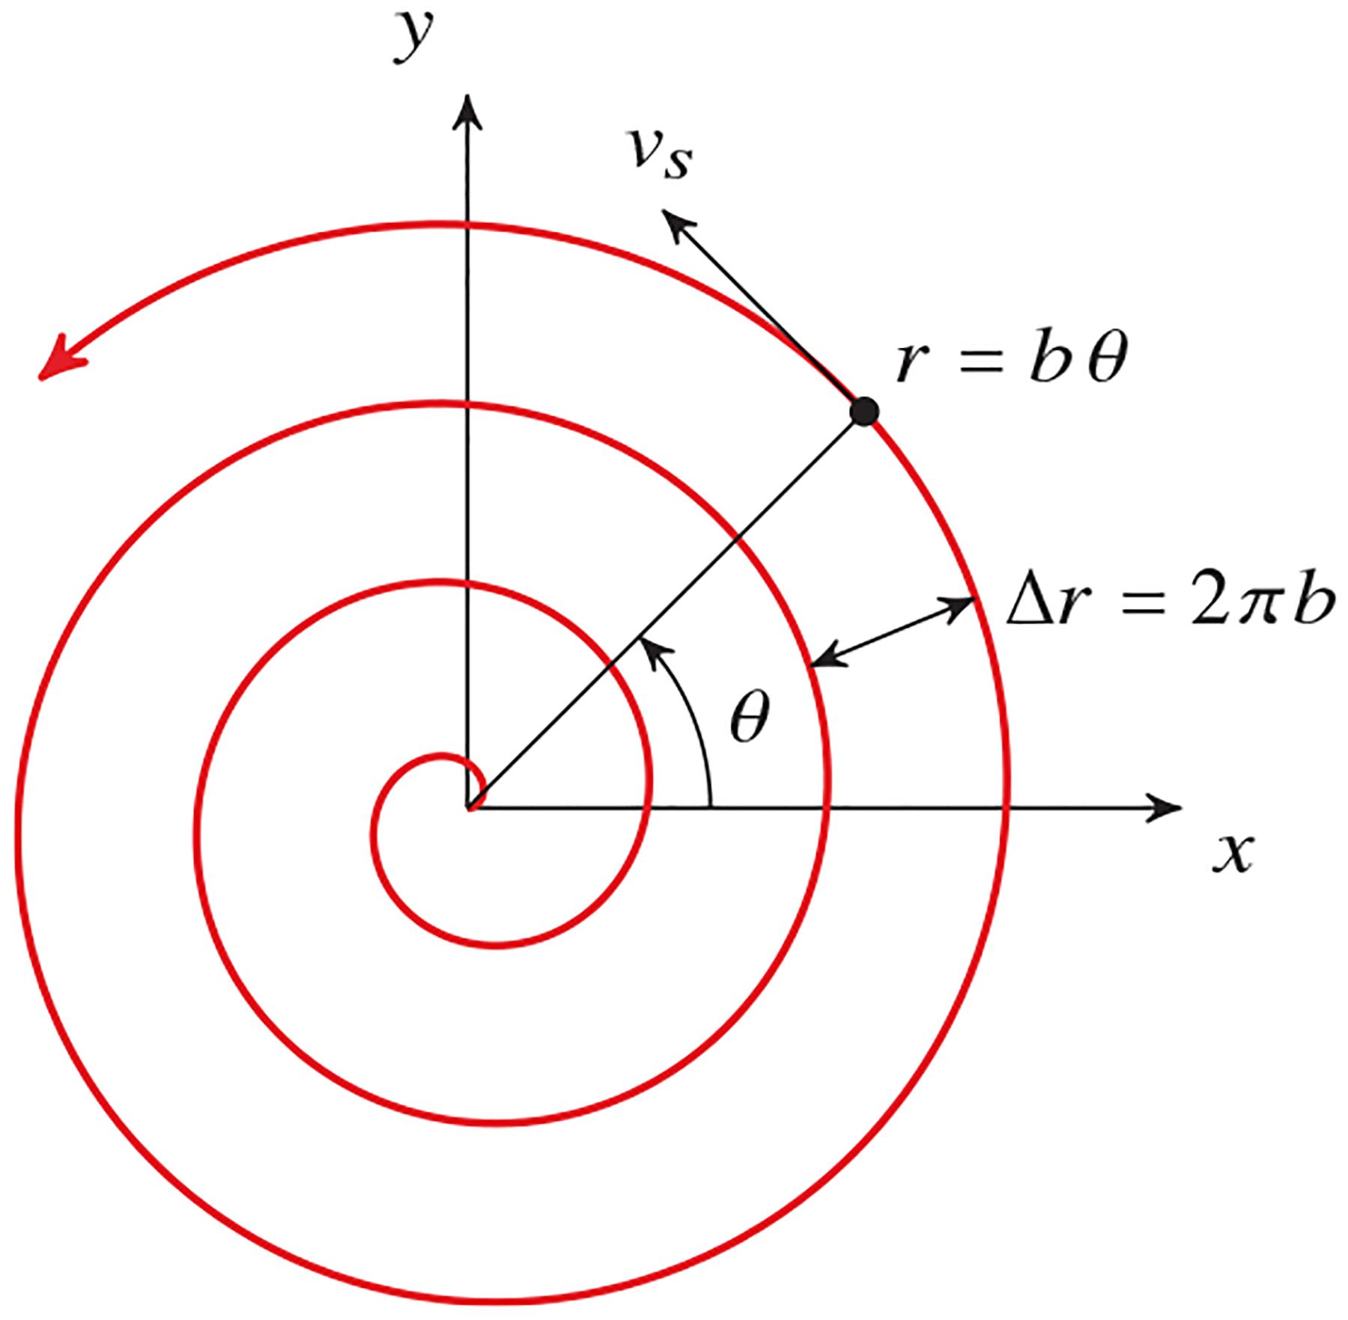
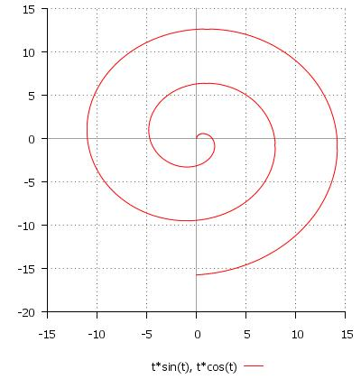
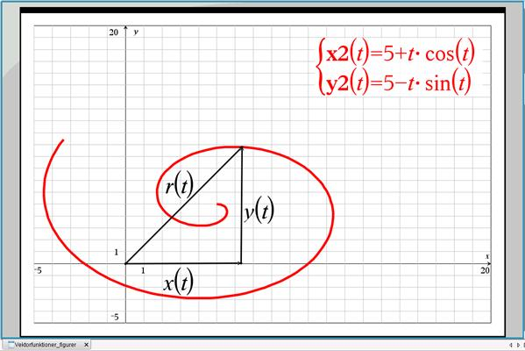
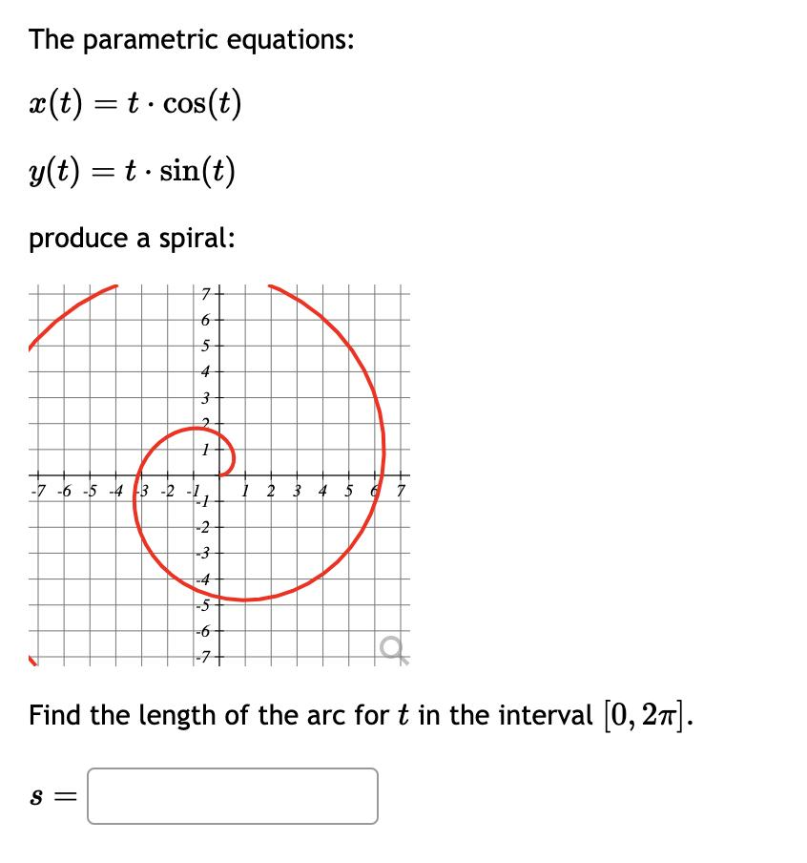
A Spiral Parametric Path describes a spiral using a parameter.
For an Archimedean spiral:
$$r=at.$$
Converting from polar to Cartesian coordinates:
$$\boxed{x=at\cos{t}, y=at\sin{t}}.$$
Example
$$x=t\cos{t}, y=t\sin{t}.$$
As $t$increases:
- the point rotates around the origin;
- its distance from the origin increases.

7. Trigonometric Parametric Path
# Source: AI Source: Provided by: [Data Path: Persons Table -> ID Column: 1, Name_En Column: Motasem Essam] -> From: [ChatGPT] on [7/25/2026]
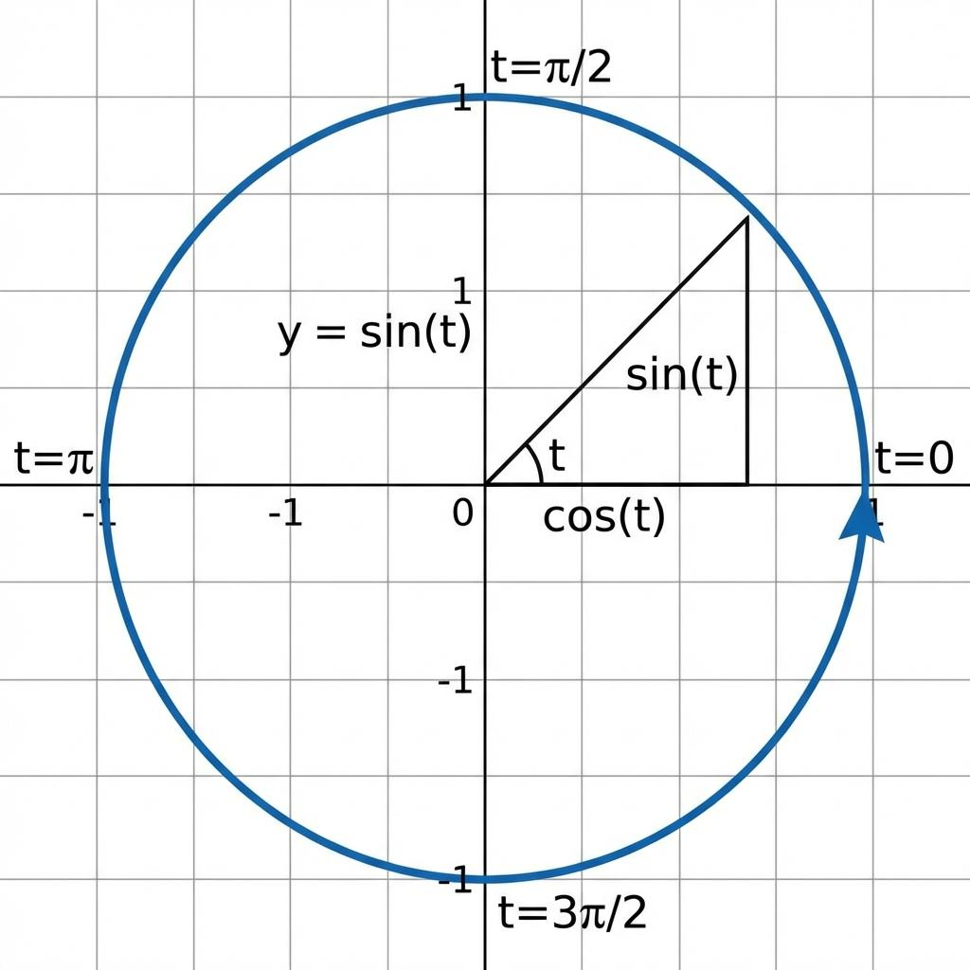
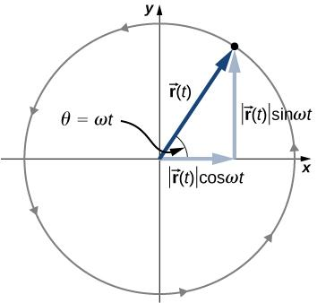
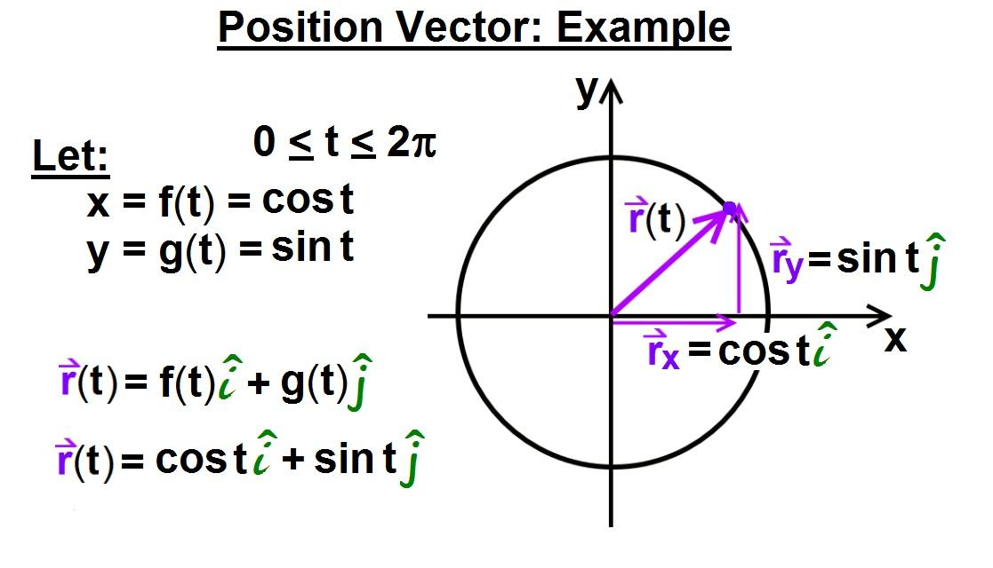
A Trigonometric Parametric Path uses trigonometric functions to define its coordinates.
$$\boxed{x=f\left(t\right), y=g\left(t\right)}$$
where $f$and/or $g$contain functions such as
$$\sin{t}, \cos{t}, \tan{t}.$$
Example
$$x=2\cos{t}, y=3\sin{t}.$$
This produces an ellipse.
A more complicated example:
$$x=sin⁡\left(2t\right), y=sin⁡\left(3t\right)$$
produces a Lissajous-type curve.

8. Polynomial Parametric Path
# Source: AI Source: Provided by: [Data Path: Persons Table -> ID Column: 1, Name_En Column: Motasem Essam] -> From: [ChatGPT] on [7/25/2026]
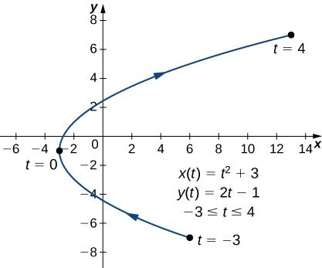
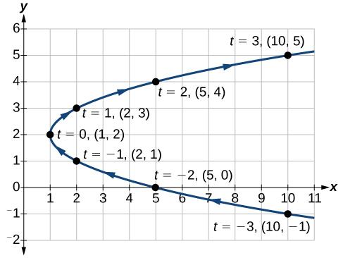
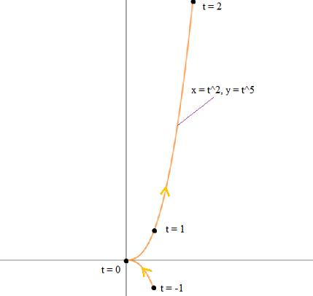
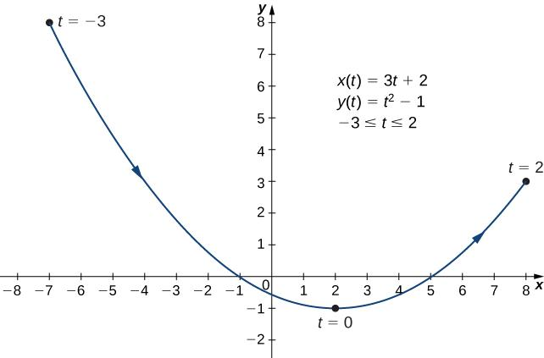
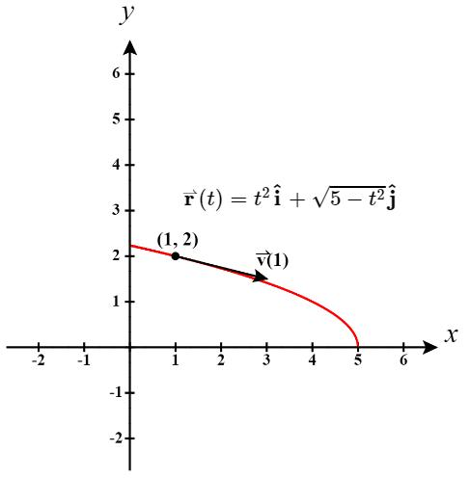
A Polynomial Parametric Path has polynomial functions as its coordinate equations.
$$\boxed{x=p\left(t\right), y=q\left(t\right)}$$
where $p\left(t\right)$and $q\left(t\right)$are polynomials.
Example
$$x=t^{2} \\ y=t^{3}.$$
Both coordinates are polynomial functions of $t$.
Another Example
$$x=t, y=t^{3}-2t.$$
This creates a cubic-type parametric curve.

9. Rational Parametric Path
# Source: AI Source: Provided by: [Data Path: Persons Table -> ID Column: 1, Name_En Column: Motasem Essam] -> From: [ChatGPT] on [7/25/2026]
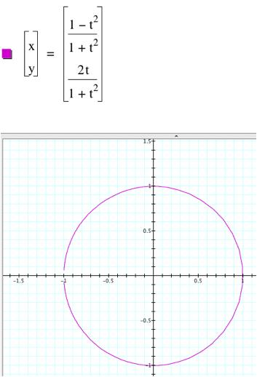
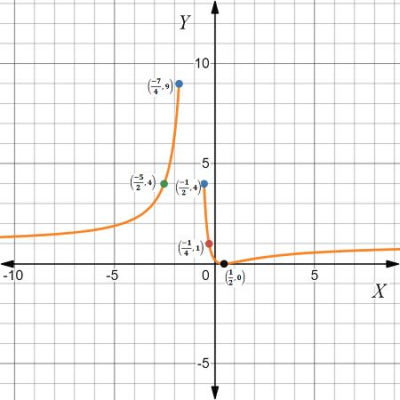
A Rational Parametric Path uses ratios of polynomial functions.
$$\boxed{x=\frac{p\left(t\right)}{r\left(t\right)}, y=\frac{q\left(t\right)}{r\left(t\right)}}$$
where the denominator is nonzero.
Example
$$x=\frac{1-t^{2}}{1+t^{2}} \\ y=\frac{2t}{1+t^{2}}.$$
This parametrizes the unit circle except for one point under the standard real-parameter interpretation.
Important Point
Rational parametrizations are especially useful for certain algebraic curves and geometric constructions.

10. Piecewise Parametric Path
# Source: AI Source: Provided by: [Data Path: Persons Table -> ID Column: 1, Name_En Column: Motasem Essam] -> From: [ChatGPT] on [7/25/2026]
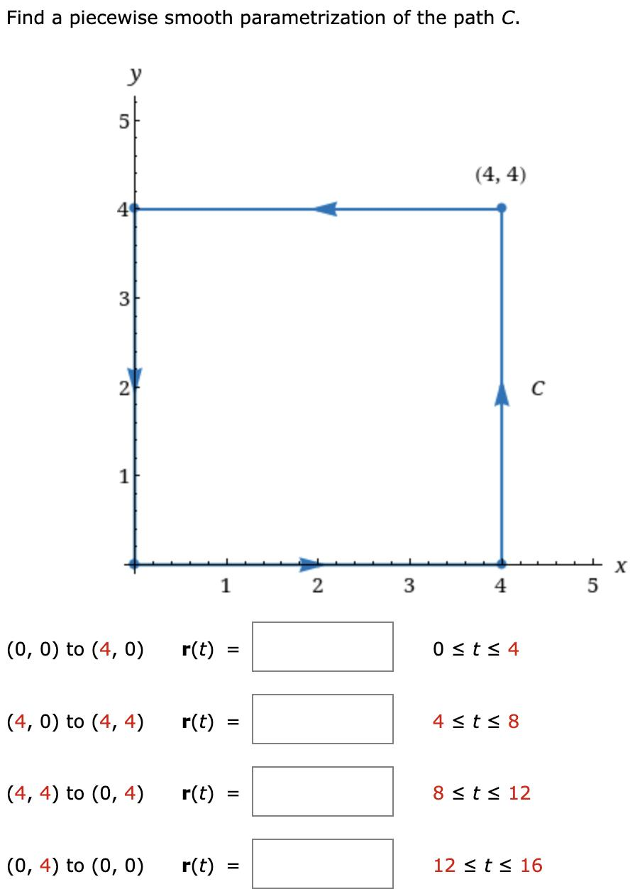
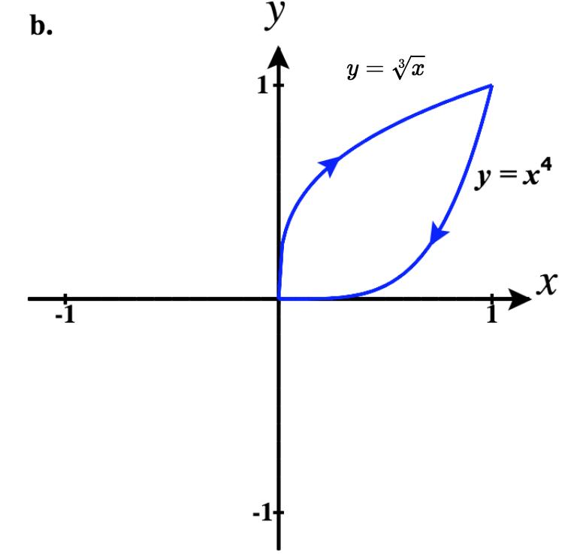
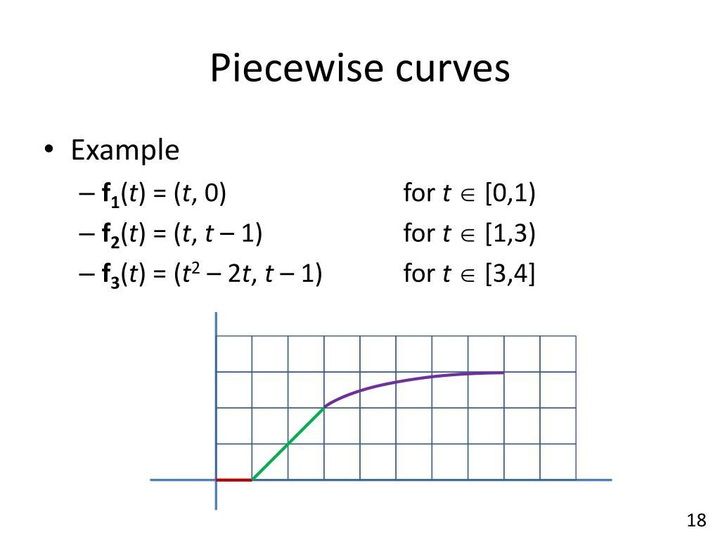
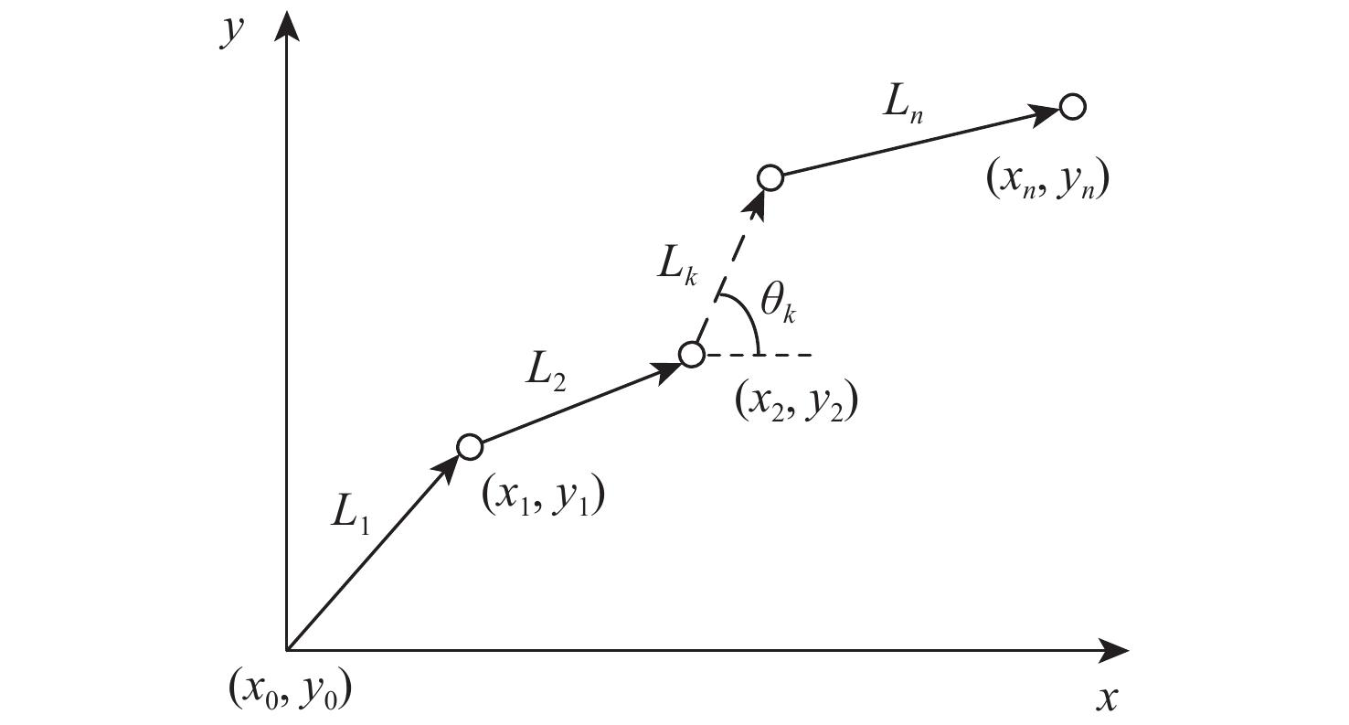
A Piecewise Parametric Path uses different parametric equations on different parameter intervals.
$$\boxed{r\left(t\right)=\left\{\begin{matrix}r_{1}\left(t\right), & t_{0}≤t≤t_{1}, \\ r_{2}\left(t\right), & t_{1}≤t≤t_{2}, \\ r_{3}\left(t\right), & t_{2}≤t≤t_{3}.\end{matrix}\right.}$$
Example
$$r\left(t\right)=\left\{\begin{matrix}\left(t , t^{2}\right), & 0≤t≤1, \\ \left(1 , +t1\right), & 1≤t≤2.\end{matrix}\right.$$
The first part is curved and the second part is straight.

11. Open Parametric Path
# Source: AI Source: Provided by: [Data Path: Persons Table -> ID Column: 1, Name_En Column: Motasem Essam] -> From: [ChatGPT] on [7/25/2026]
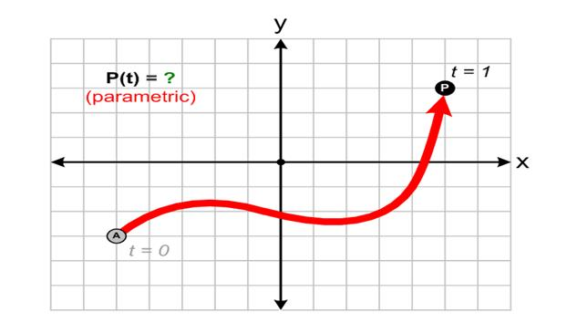
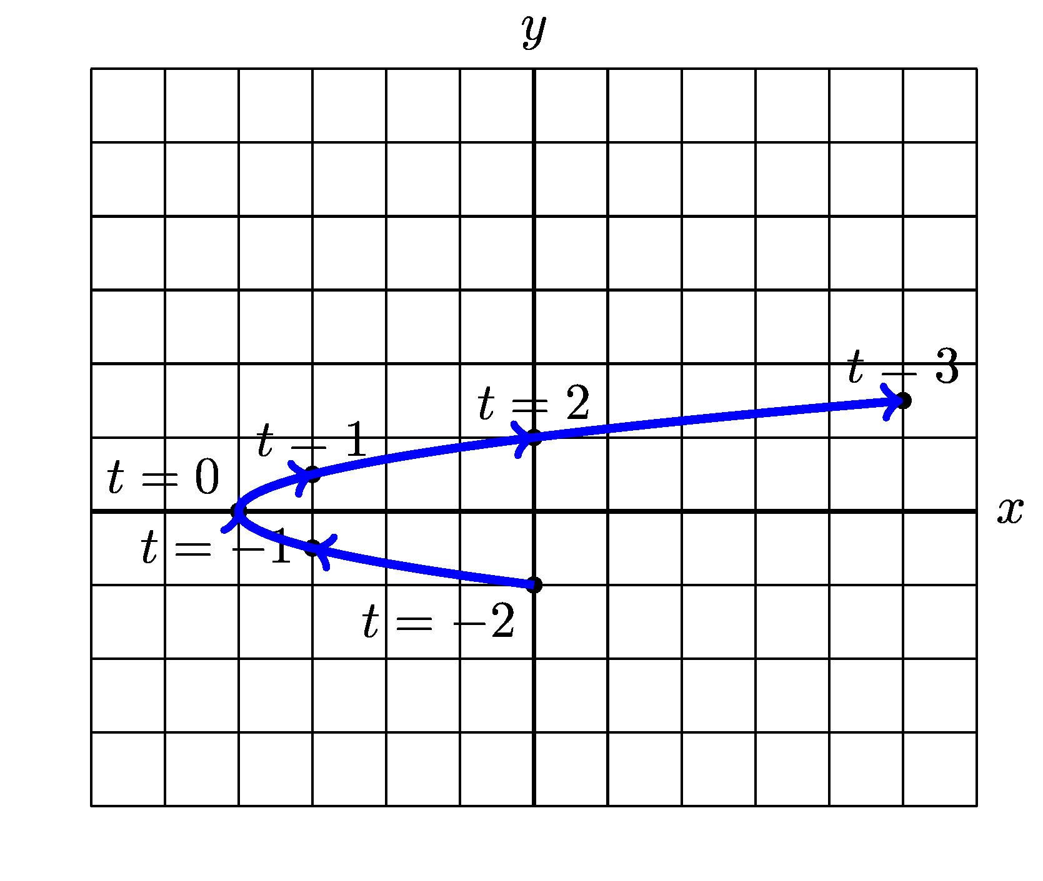
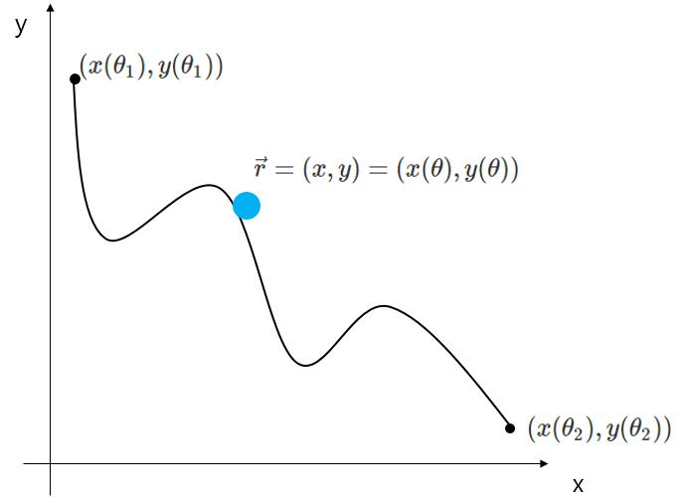
An Open Parametric Path has different starting and ending points.
If
$$r\left(t_{0}\right)≠r\left(t_{1}\right),$$
then the parameterized path is open over that interval.
Example
$$r\left(t\right)=\left\langle t , t^{2}\right\rangle , -1≤t≤1.$$
The starting point and ending point are
$$\left(- , 11\right)$$
and
$$\left(1 , 1\right).$$

12. Closed Parametric Path
# Source: AI Source: Provided by: [Data Path: Persons Table -> ID Column: 1, Name_En Column: Motasem Essam] -> From: [ChatGPT] on [7/25/2026]
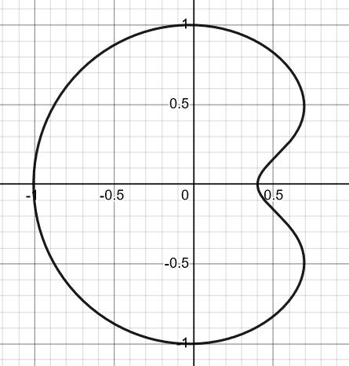
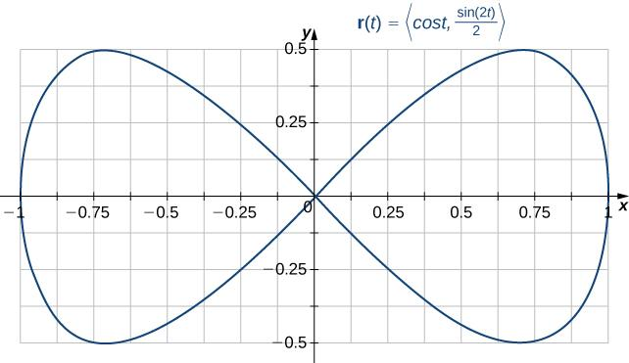
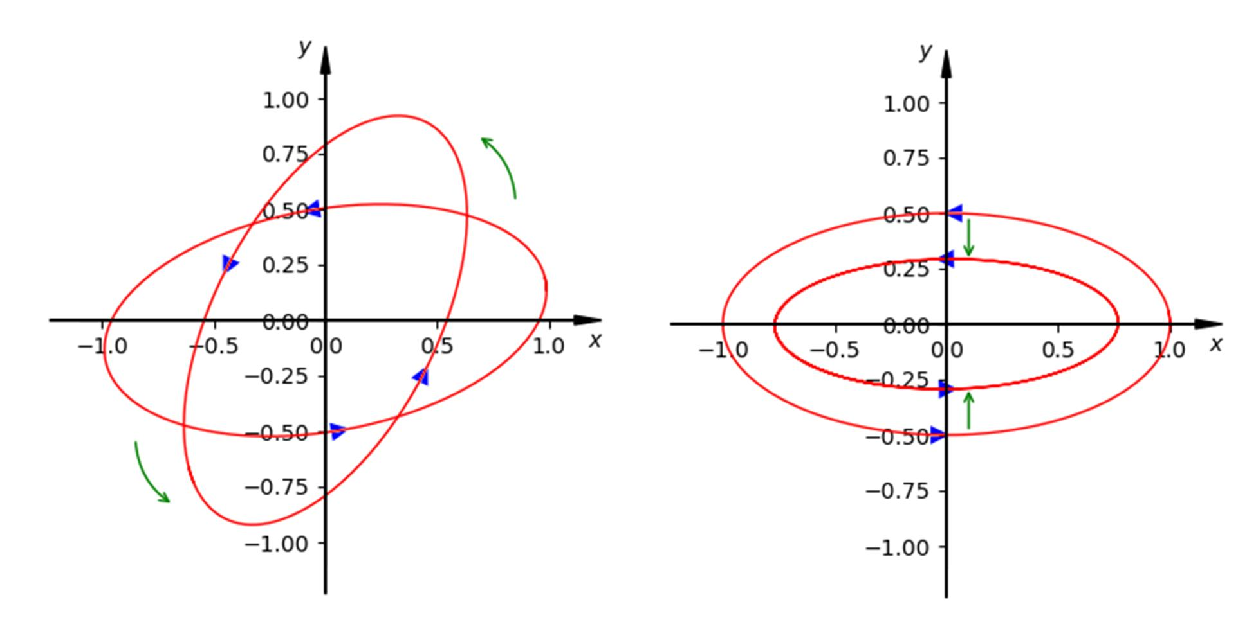
A Closed Parametric Path returns to its starting point.
$$\boxed{r\left(t_{0}\right)=r\left(t_{1}\right)}$$
Example
$$r\left(t\right)=\left\langle \cos{t} , \sin{t}\right\rangle , 0≤t≤2π.$$
Since
$$r\left(0\right)=r\left(2π\right)=\left(1 , 0\right),$$
the path is closed.

13. Simple Parametric Path
# Source: AI Source: Provided by: [Data Path: Persons Table -> ID Column: 1, Name_En Column: Motasem Essam] -> From: [ChatGPT] on [7/25/2026]
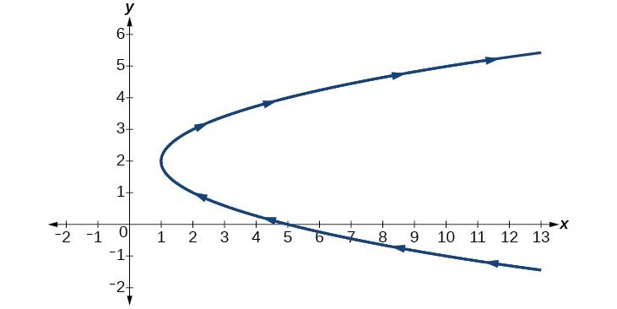
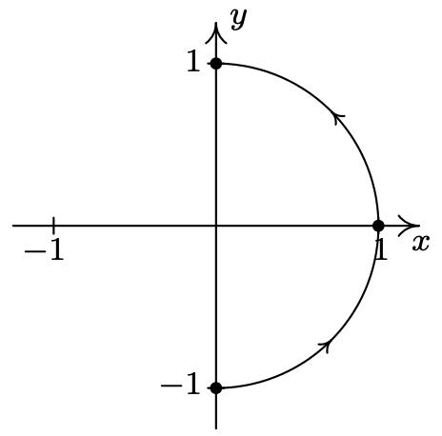
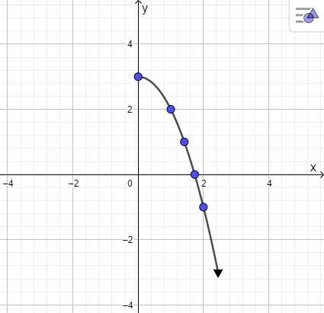
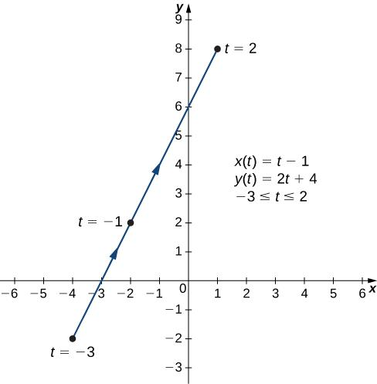
A Simple Parametric Path does not cross itself.
For a simple open path,
$$r\left(t_{1}\right)≠r\left(t_{2}\right)$$
whenever
$$t_{1}≠t_{2}.$$
For a simple closed path, the initial and final parameter values are allowed to represent the same point.
Example
An ellipse traced once is a simple closed parametric path.

14. Self-Intersecting Parametric Path
# Source: AI Source: Provided by: [Data Path: Persons Table -> ID Column: 1, Name_En Column: Motasem Essam] -> From: [ChatGPT] on [7/25/2026]
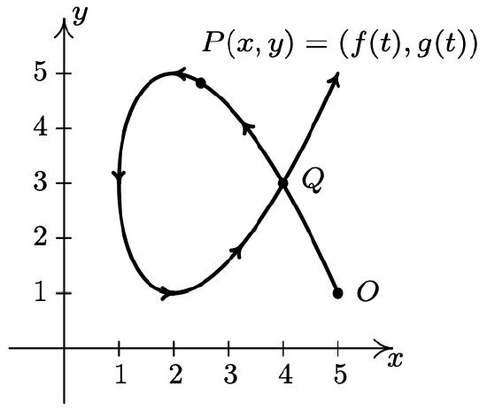
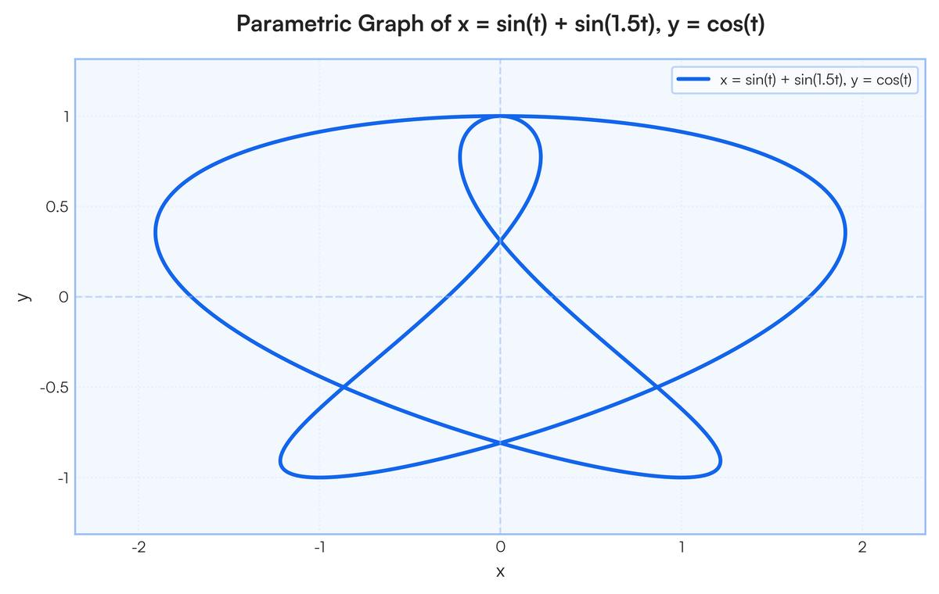
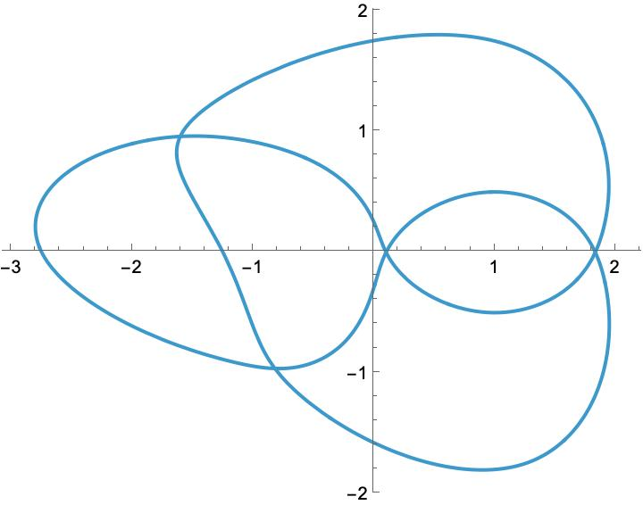
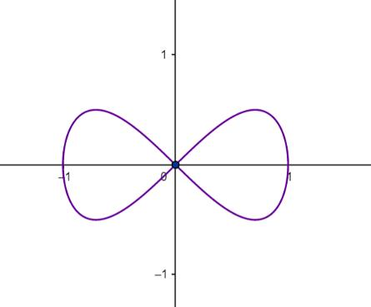
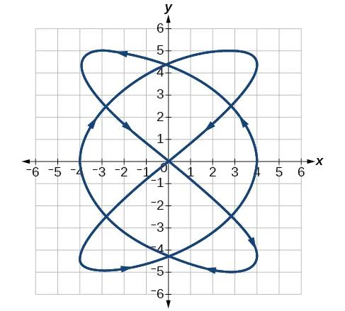
A Self-Intersecting Parametric Path passes through the same point for different parameter values.
$$\boxed{r\left(t_{1}\right)=r\left(t_{2}\right), t_{1}≠t_{2}}$$
Example
A figure-eight-type parametric curve can be self-intersecting.
For example:
$$x=\sin{t}, y=sin⁡\left(2t\right).$$
The path crosses itself.

15. Planar Parametric Path
# Source: AI Source: Provided by: [Data Path: Persons Table -> ID Column: 1, Name_En Column: Motasem Essam] -> From: [ChatGPT] on [7/25/2026]
A Planar Parametric Path lies entirely in a single plane.
In two dimensions:
$$\boxed{r\left(t\right)=\left\langle x , \left(t\right)y\left(t\right)\right\rangle }$$
Example
$$r\left(t\right)=\left\langle t , t^{2}\right\rangle$$
lies in the $xy$-plane.
Most elementary parametric curves are planar.

16. Spatial Parametric Path
# Source: AI Source: Provided by: [Data Path: Persons Table -> ID Column: 1, Name_En Column: Motasem Essam] -> From: [ChatGPT] on [7/25/2026]
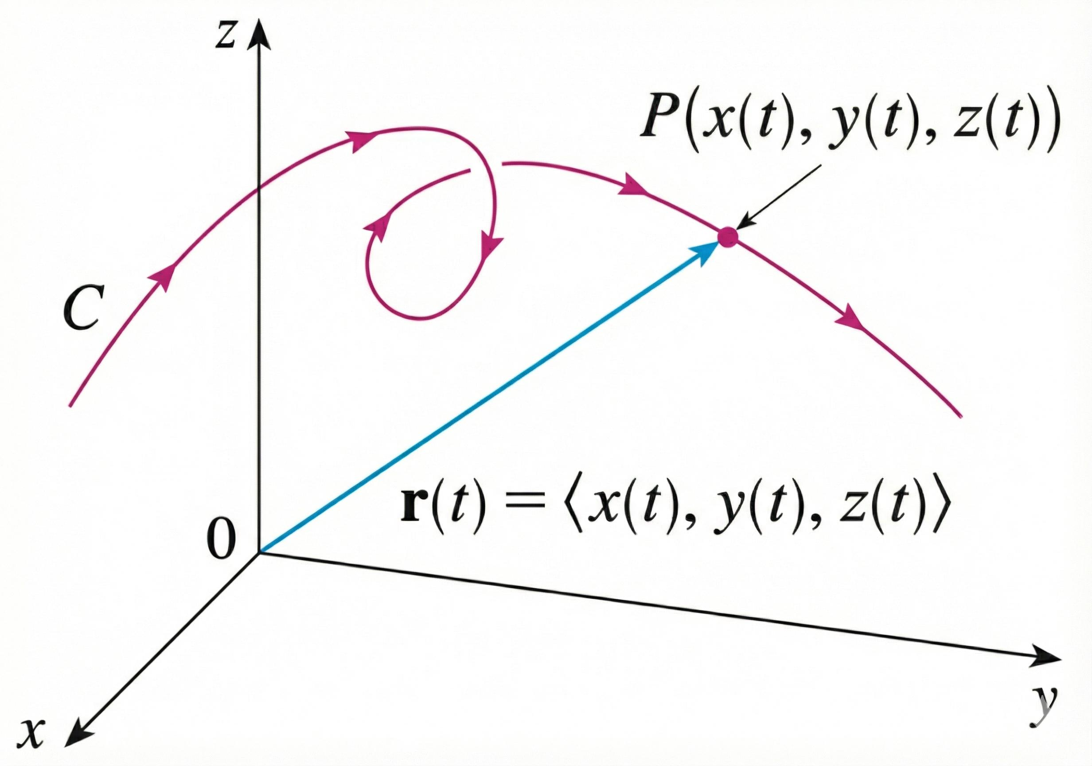
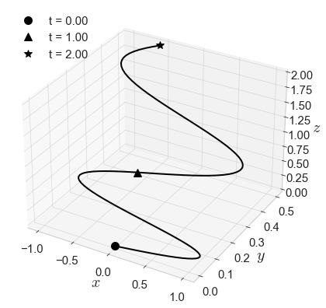
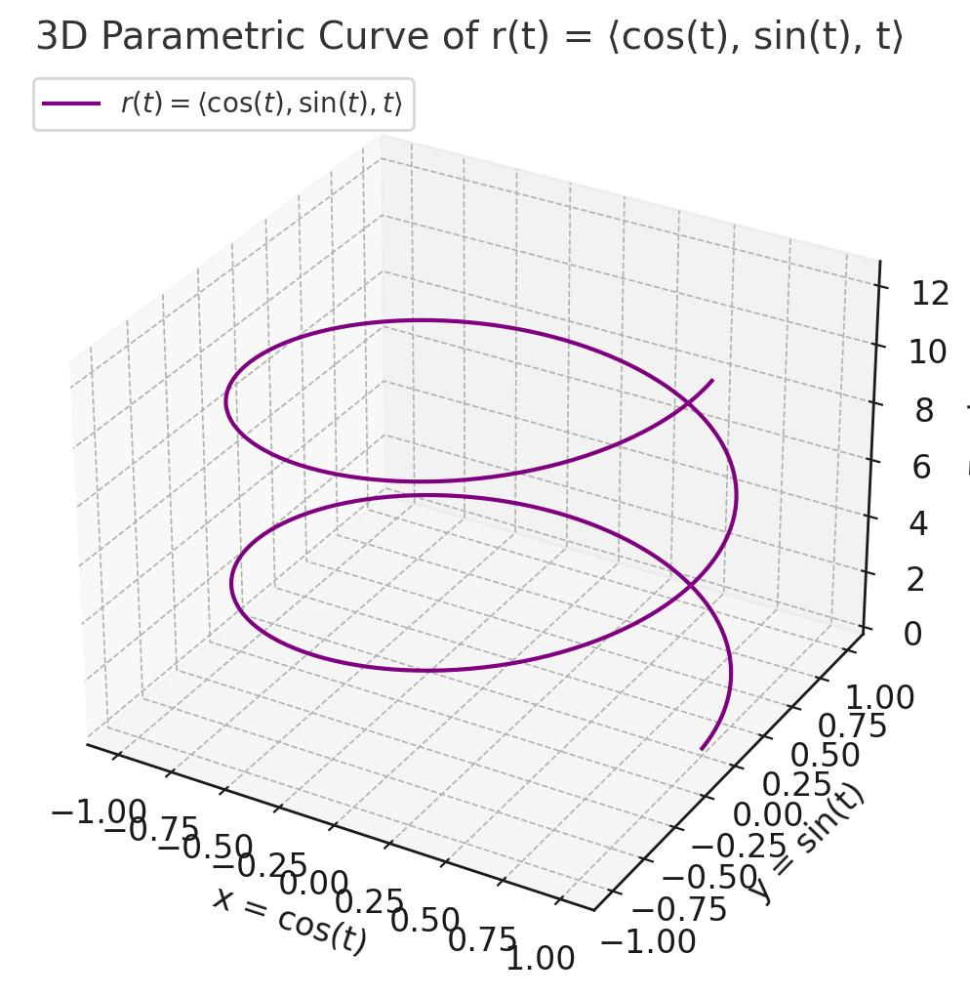
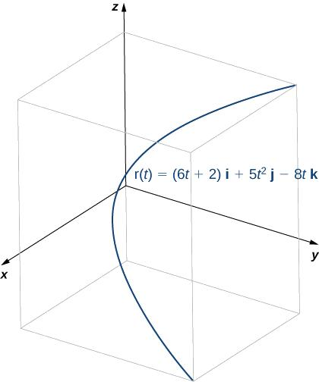
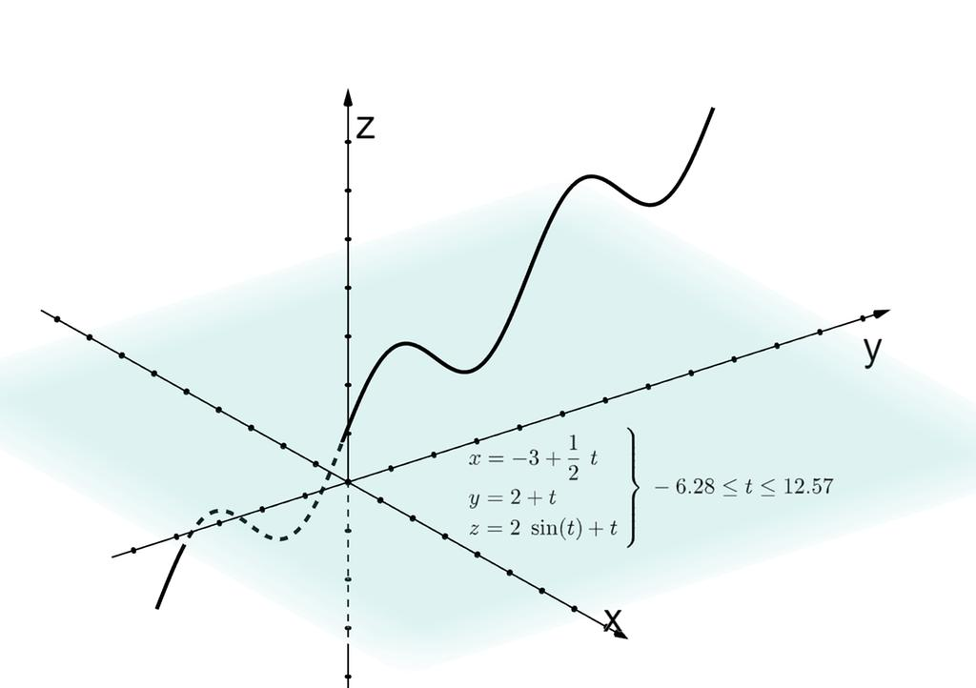
A Spatial Parametric Path exists in three-dimensional space.
$$\boxed{r\left(t\right)=\left\langle x , \left(t\right) , y\left(t\right)z\left(t\right)\right\rangle }$$
Example
A helix can be represented by
$$\boxed{x=\cos{t}, y=\sin{t}, z=t}$$
As $t$increases, the point travels around the $z$-axis while simultaneously moving upward.

17. Uniformly Parameterized Path
# Source: AI Source: Provided by: [Data Path: Persons Table -> ID Column: 1, Name_En Column: Motasem Essam] -> From: [ChatGPT] on [7/25/2026]
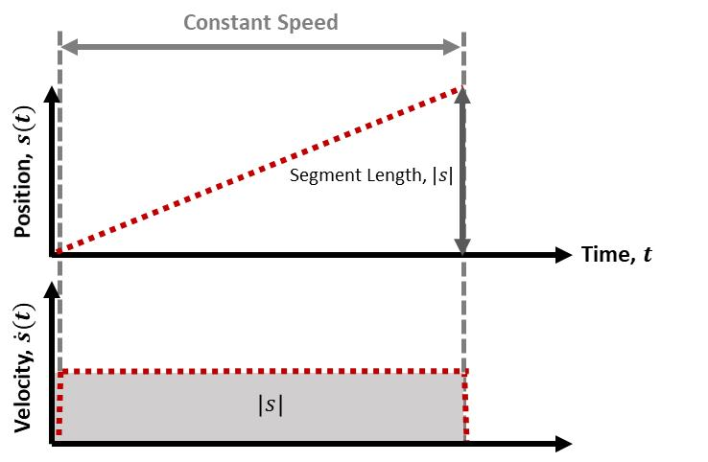
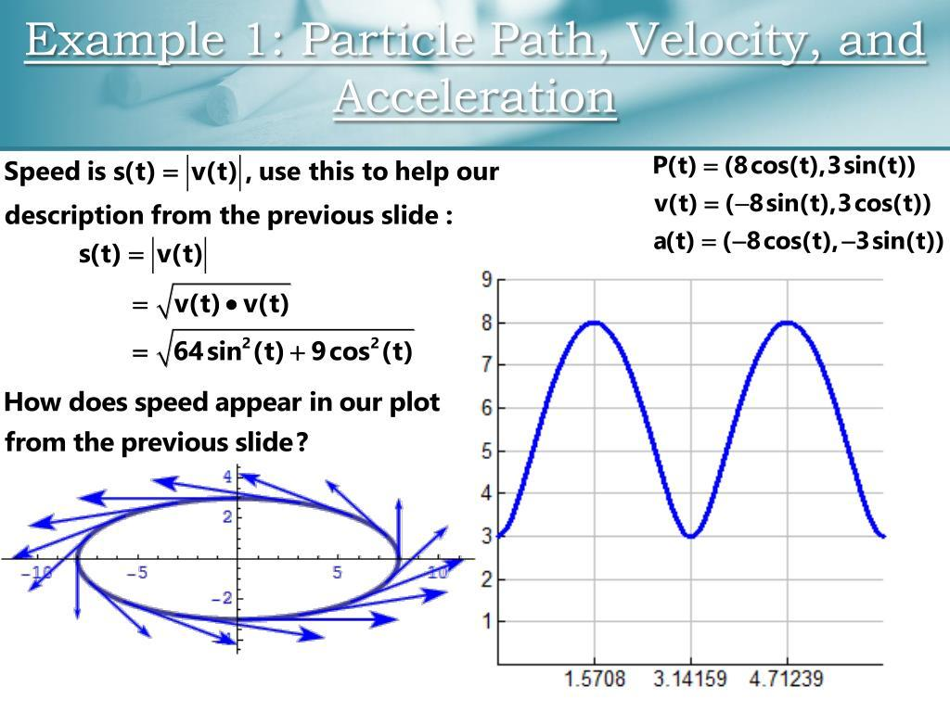
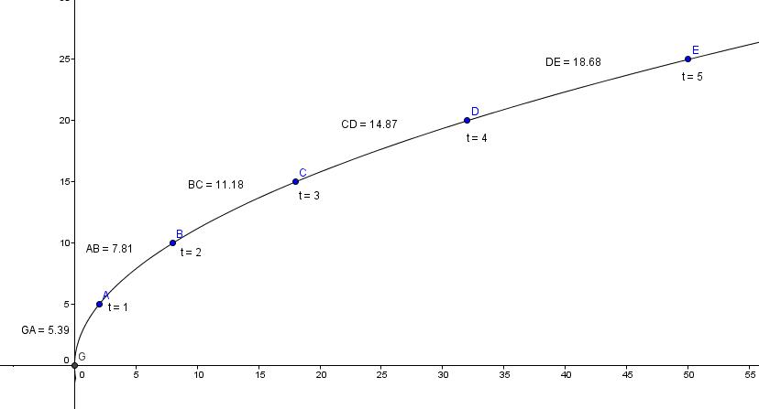
A Uniformly Parameterized Path is parameterized so that the point moves with constant speed with respect to the parameter.
The speed is
$$\boxed{v=∥r^{'}\left(t\right)∥}$$
and uniform parameterization requires
$$\boxed{∥r^{'}\left(t\right)∥=\text{constant}}$$
over the relevant interval.
Example
A straight-line path
$$r\left(t\right)=A+tv$$
has
$$r^{'}\left(t\right)=v,$$
so its speed is constant.
Important Distinction
Uniform parameterization concerns how the path is traversed, not merely the shape of the path.

18. Non-Uniformly Parameterized Path
# Source: AI Source: Provided by: [Data Path: Persons Table -> ID Column: 1, Name_En Column: Motasem Essam] -> From: [ChatGPT] on [7/25/2026]
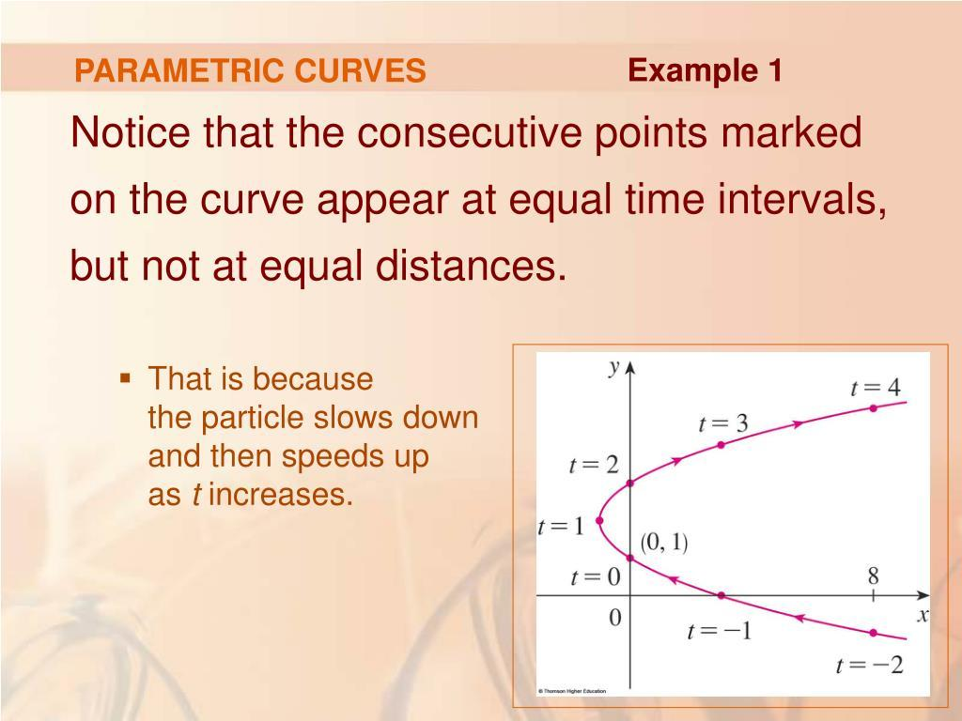
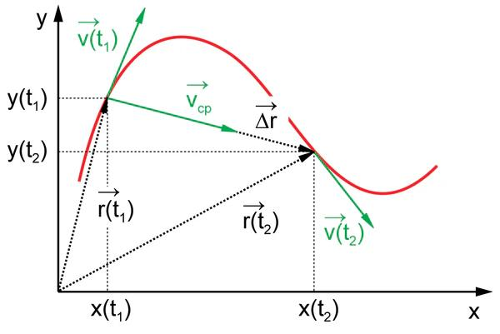
A Non-Uniformly Parameterized Path has changing speed with respect to the parameter.
$$\boxed{∥r^{'}\left(t\right)∥≠\text{constant}}$$
Example
$$r\left(t\right)=\left\langle t^{2} , t^{4}\right\rangle .$$
The point does not generally travel at constant speed as $t$changes.
Important Point
The same geometric curve can have either a uniform or non-uniform parameterization.

19. Restricted Parametric Path
# Source: AI Source: Provided by: [Data Path: Persons Table -> ID Column: 1, Name_En Column: Motasem Essam] -> From: [ChatGPT] on [7/25/2026]
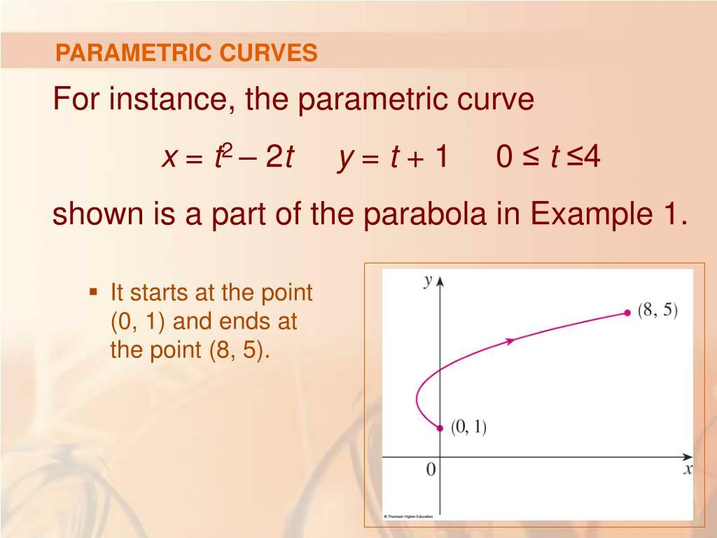
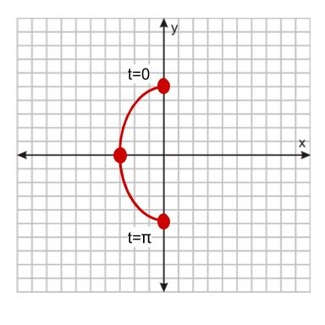
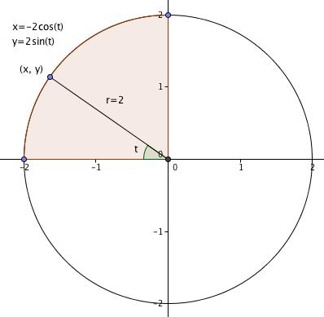
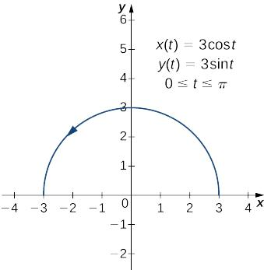
A Restricted Parametric Path uses a parameter over a limited interval.
For example:
$$x=\cos{t}, y=\sin{t},$$
with
$$0≤t≤\frac{π}{2}.$$
This traces only a quarter of the circle.
Example
$$\boxed{0≤t≤\frac{π}{2}}$$
produces the first-quadrant quarter-circle.

20. Combined Parametric Path
# Source: AI Source: Provided by: [Data Path: Persons Table -> ID Column: 1, Name_En Column: Motasem Essam] -> From: [ChatGPT] on [7/25/2026]
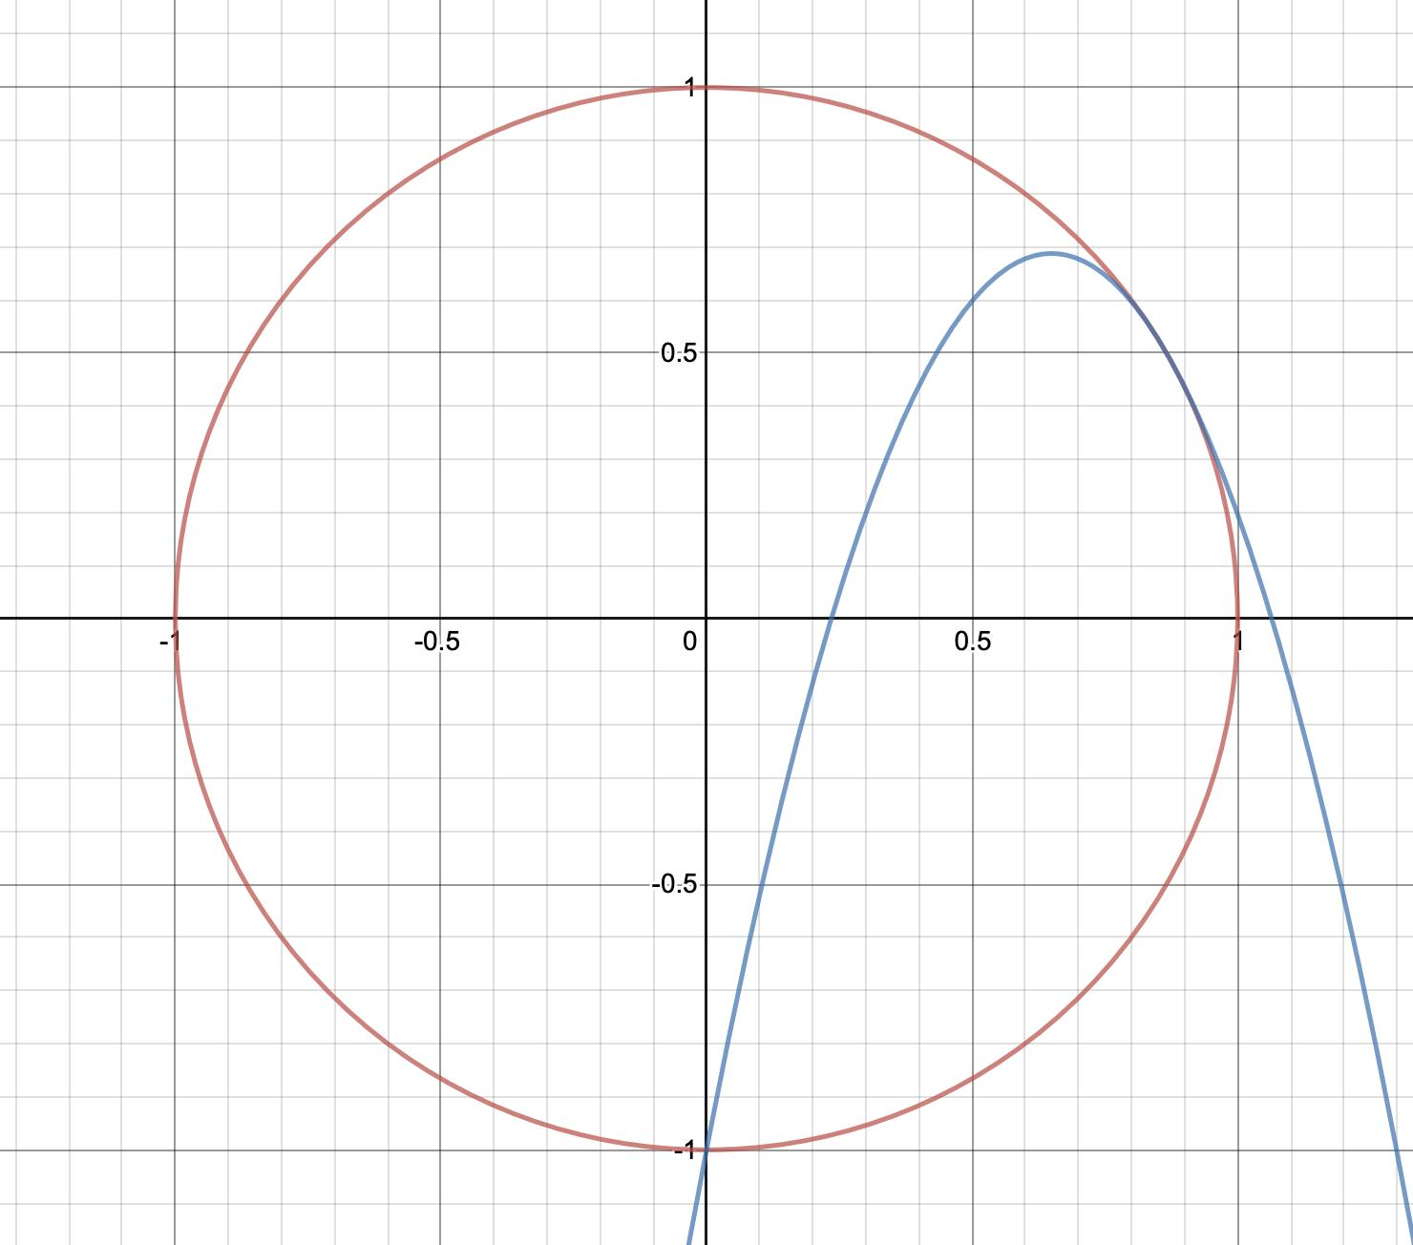
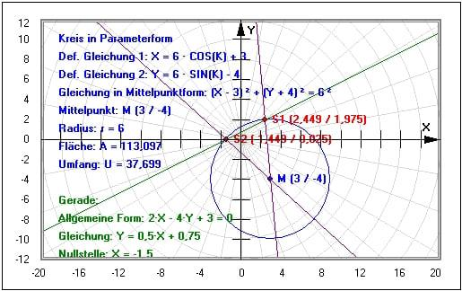
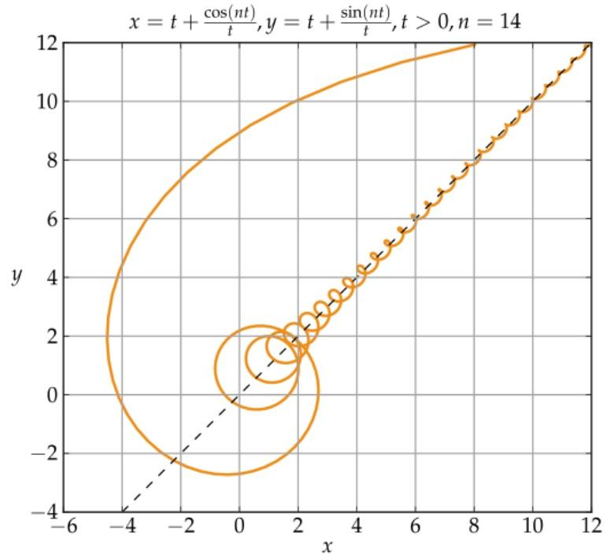
A Combined Parametric Path combines different types of parametric pieces.
For example:
$$\text{Line}→\text{Circular Arc}→\text{Parabolic Arc}.$$
It can be represented by a piecewise vector function:
$$r\left(t\right)=\left\{\begin{matrix}r_{1}\left(t\right), & t_{0}≤t<t_{1}, \\ r_{2}\left(t\right), & t_{1}≤t<t_{2}, \\ r_{3}\left(t\right), & t_{2}≤t≤t_{3}.\end{matrix}\right.$$
This is useful when a single equation cannot conveniently describe the entire path.

Why Use Parametric Paths?
# Source: AI Source: Provided by: [Data Path: Persons Table -> ID Column: 1, Name_En Column: Motasem Essam] -> From: [ChatGPT] on [7/25/2026]
Parametric equations are particularly useful because they describe both position and progression along a path.
A Cartesian equation such as
$$y=x^{2}$$
primarily describes the geometric relationship between $x$and $y$.
A parametric representation
$$x=t, y=t^{2}$$
also tells us how the point progresses as $t$changes.
For example:
$$t=0→\left(0 , 0\right) \\ t=1→\left(1 , 1\right) \\ t=2→\left(2 , 4\right).$$

Eliminating the Parameter
# Source: AI Source: Provided by: [Data Path: Persons Table -> ID Column: 1, Name_En Column: Motasem Essam] -> From: [ChatGPT] on [7/25/2026]
A parametric path can sometimes be converted into a conventional Cartesian equation.
Suppose
$$x=t, y=t^{2}.$$
From
$$x=t,$$
we obtain
$$t=x.$$
Substitute into $y=t^{2}$:
$$\boxed{y=x^{2}}.$$
Thus:
$$\boxed{x=t, y=t^{2} ⟺ y=x^{2}}$$
for the corresponding parameter range.
However, not every parametric representation is conveniently converted into a single Cartesian equation.

Direction and Tangent of a Parametric Path
# Source: AI Source: Provided by: [Data Path: Persons Table -> ID Column: 1, Name_En Column: Motasem Essam] -> From: [ChatGPT] on [7/25/2026]
For
$$r\left(t\right)=\left\langle x , \left(t\right)y\left(t\right)\right\rangle ,$$
the tangent vector is
$$\boxed{r^{'}\left(t\right)=\left\langle x^{'} , \left(t\right)y^{'}\left(t\right)\right\rangle }$$
when the derivative exists.
The tangent slope, when $x^{'}\left(t\right)≠0$, is
$$\boxed{\frac{dy}{dx}=\frac{dy/dt}{dx/dt}=\frac{y^{'}\left(t\right)}{x^{'}\left(t\right)}}$$
Example
For
$$x=t, y=t^{2},$$
we have
$$x^{'}=1, y^{'}=2t.$$
Therefore:
$$\boxed{\frac{dy}{dx}=2t}$$
and since $t=x$,
$$\frac{dy}{dx}=2x.$$

Speed Along a Parametric Path
# Source: AI Source: Provided by: [Data Path: Persons Table -> ID Column: 1, Name_En Column: Motasem Essam] -> From: [ChatGPT] on [7/25/2026]
For
$$r\left(t\right)=\left\langle x , \left(t\right)y\left(t\right)\right\rangle ,$$
the speed is
$$\boxed{v\left(t\right)=\sqrt{x^{'}{\left(t\right)}^{2}+y^{'}{\left(t\right)}^{2}}}$$
Example
For
$$x=\cos{t}, y=\sin{t},$$
we have
$$x^{'}=-\sin{t}, y^{'}=\cos{t}.$$
Therefore:
$$v\left(t\right)=\sqrt{\sin^{2}t+\cos^{2}t}=1.$$
Thus the standard circular parameterization traces the unit circle at constant speed.

Arc Length of a Parametric Path
# Source: AI Source: Provided by: [Data Path: Persons Table -> ID Column: 1, Name_En Column: Motasem Essam] -> From: [ChatGPT] on [7/25/2026]
For
$$x=x\left(t\right), y=y\left(t\right),$$
the arc length from $t=a$to $t=b$is
$$\boxed{L=\int_{a}^{b}{\sqrt{{\left(\frac{dx}{dt}\right)}^{2}+{\left(\frac{dy}{dt}\right)}^{2}}} dt}$$
Example: Unit Circle
$$x=\cos{t}, y=\sin{t}$$
for
$$0≤t≤2π.$$
Then
$$L=\int_{0}^{2π}{1} dt=2π.$$

Parametric Path in Three Dimensions
# Source: AI Source: Provided by: [Data Path: Persons Table -> ID Column: 1, Name_En Column: Motasem Essam] -> From: [ChatGPT] on [7/25/2026]
A three-dimensional path is represented by
$$\boxed{r\left(t\right)=\left\langle x , \left(t\right) , y\left(t\right)z\left(t\right)\right\rangle }$$
The velocity vector is
$$\boxed{v\left(t\right)=r^{'}\left(t\right)}$$
and speed is
$$\boxed{v\left(t\right)=\sqrt{x^{'}{\left(t\right)}^{2}+y^{'}{\left(t\right)}^{2}+z^{'}{\left(t\right)}^{2}}}$$
Example: Helical Path
$$x=\cos{t}, \\ y=\sin{t}, \\ z=t.$$
This creates a helix around the $z$-axis.

Parametric Path and Motion
# Source: AI Source: Provided by: [Data Path: Persons Table -> ID Column: 1, Name_En Column: Motasem Essam] -> From: [ChatGPT] on [7/25/2026]
When $t$represents time, the parametric path becomes a trajectory.
$$\boxed{r\left(t\right)=\text{position of the object at time }t}$$
Then:
Position
$$r\left(t\right)$$
Velocity
$$\boxed{v\left(t\right)=r^{'}\left(t\right)}$$
Acceleration
$$\boxed{a\left(t\right)=r^{''}\left(t\right)}$$
This makes parametric paths especially useful in:
- mechanics
- robotics
- animation
- computer graphics
- trajectory planning
- engineering
- navigation.

Parametric Path vs Coordinate Path
# Source: AI Source: Provided by: [Data Path: Persons Table -> ID Column: 1, Name_En Column: Motasem Essam] -> From: [ChatGPT] on [7/25/2026]
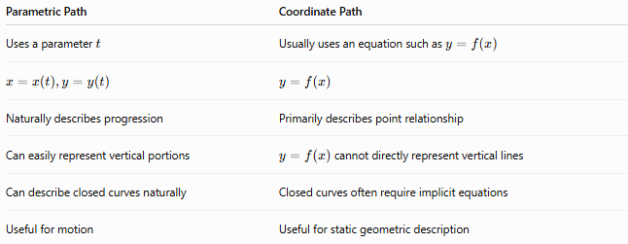
Parametric Path | Coordinate Path
Uses a parameter $t$ | Usually uses an equation such as $y=f\left(x\right)$
$$x=x\left(t\right),y=y\left(t\right)$$ | $$y=f\left(x\right)$$
Naturally describes progression | Primarily describes point relationship
Can easily represent vertical portions | $y=f\left(x\right)$cannot directly represent vertical lines
Can describe closed curves naturally | Closed curves often require implicit equations
Useful for motion | Useful for static geometric description
For example:
$$\boxed{x=t, y=t^{2}}$$
is parametric, while
$$\boxed{y=x^{2}}$$
is a Cartesian coordinate equation.

Parametric Path vs Piecewise Path
# Source: AI Source: Provided by: [Data Path: Persons Table -> ID Column: 1, Name_En Column: Motasem Essam] -> From: [ChatGPT] on [7/25/2026]
These concepts are related but not identical.
A Parametric Path describes a path using a parameter.
A Piecewise Path divides a path into multiple pieces.
Therefore, a path can be both:
$$\boxed{\text{Parametric and Piecewise}}$$
For example:
$$r\left(t\right)=\left\{\begin{matrix}r_{1}\left(t\right), & 0≤t≤1, \\ r_{2}\left(t\right), & 1≤t≤2.\end{matrix}\right.$$
is a Piecewise Parametric Path.

Parametric Path vs Curved Path
# Source: AI Source: Provided by: [Data Path: Persons Table -> ID Column: 1, Name_En Column: Motasem Essam] -> From: [ChatGPT] on [7/25/2026]
These terms classify paths according to different properties.
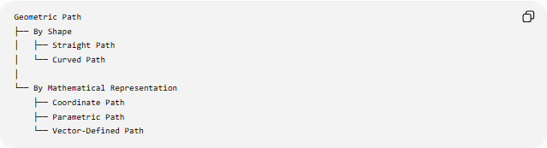
Geometric Path
├── By Shape
│ ├── Straight Path
│ └── Curved Path
│
└── By Mathematical Representation
├── Coordinate Path
├── Parametric Path
└── Vector-Defined Path
Therefore, Parametric Path is not necessarily curved.
A parametric path can be:
- straight,
- circular,
- elliptical,
- parabolic,
- spatial,
- piecewise,
- etc.
For example:
$$x=t, y=2t$$
is a parametric straight-line path.
While
$$x=\cos{t}, y=\sin{t}$$
is a parametric curved path.

Classification Summary
# Source: AI Source: Provided by: [Data Path: Persons Table -> ID Column: 1, Name_En Column: Motasem Essam] -> From: [ChatGPT] on [7/25/2026]
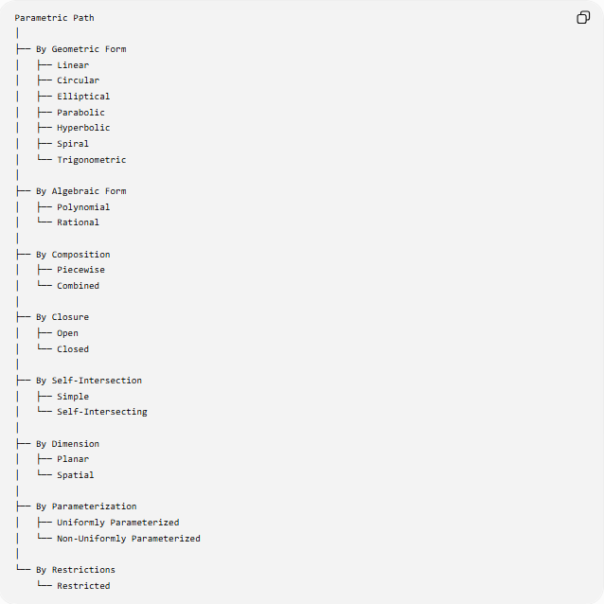
Parametric Path
│
├── By Geometric Form
│ ├── Linear
│ ├── Circular
│ ├── Elliptical
│ ├── Parabolic
│ ├── Hyperbolic
│ ├── Spiral
│ └── Trigonometric
│
├── By Algebraic Form
│ ├── Polynomial
│ └── Rational
│
├── By Composition
│ ├── Piecewise
│ └── Combined
│
├── By Closure
│ ├── Open
│ └── Closed
│
├── By Self-Intersection
│ ├── Simple
│ └── Self-Intersecting
│
├── By Dimension
│ ├── Planar
│ └── Spatial
│
├── By Parameterization
│ ├── Uniformly Parameterized
│ └── Non-Uniformly Parameterized
│
└── By Restrictions
└── Restricted

Key Formulas
# Source: AI Source: Provided by: [Data Path: Persons Table -> ID Column: 1, Name_En Column: Motasem Essam] -> From: [ChatGPT] on [7/25/2026]
General 2D Parametric Path
$$\boxed{x=x\left(t\right), y=y\left(t\right)}$$
Vector Form
$$\boxed{r\left(t\right)=\left\langle x , \left(t\right)y\left(t\right)\right\rangle }$$
3D Parametric Path
$$\boxed{r\left(t\right)=\left\langle x , \left(t\right) , y\left(t\right)z\left(t\right)\right\rangle }$$
Straight Line
$$\boxed{r\left(t\right)=A+tv}$$
Circle
$$\boxed{x=h+r\cos{t}, y=k+r\sin{t}}$$
Ellipse
$$\boxed{x=h+a\cos{t}, y=k+b\sin{t}}$$
Parabola
$$\boxed{x=at^{2}, y=2at}$$
Spiral
$$\boxed{x=at\cos{t}, y=at\sin{t}}$$
Tangent Slope
$$\boxed{\frac{dy}{dx}=\frac{y^{'}\left(t\right)}{x^{'}\left(t\right)}}$$
Speed
$$\boxed{v\left(t\right)=\sqrt{x^{'}{\left(t\right)}^{2}+y^{'}{\left(t\right)}^{2}}}$$
Arc Length
$$\boxed{L=\int_{a}^{b}{\sqrt{x^{'}{\left(t\right)}^{2}+y^{'}{\left(t\right)}^{2}}} dt}$$
Velocity
$$\boxed{v\left(t\right)=r^{'}\left(t\right)}$$
Acceleration
$$\boxed{a\left(t\right)=r^{''}\left(t\right)}$$

Key Points
# Source: AI Source: Provided by: [Data Path: Persons Table -> ID Column: 1, Name_En Column: Motasem Essam] -> From: [ChatGPT] on [7/25/2026]
- A Parametric Path describes position using a parameter.
- The standard form is:
$$x=x\left(t\right), y=y\left(t\right).$$
- The parameter $t$does not necessarily mean time.
- A parametric path can be straight or curved.
- Circular, elliptical, parabolic, hyperbolic, and spiral paths can all be parameterized.
- Parametric equations are particularly useful for closed curves.
- They can represent vertical and multiple-valued curves naturally.
- The derivative $r^{'}\left(t\right)$gives the tangent/velocity direction.
- The magnitude $∥r^{'}\left(t\right)∥$gives speed when $t$represents time.
- The second derivative gives acceleration when $t$is time.
- A path may be uniformly or non-uniformly parameterized.
- A parametric path may be planar or spatial.
- A piecewise path can be represented parametrically.
- Restricting the parameter interval restricts the portion of the path traced.
- Parametric paths are fundamental in coordinate geometry, calculus, physics, robotics, computer graphics, and geometric modeling.

Conclusion
# Source: AI Source: Provided by: [Data Path: Persons Table -> ID Column: 1, Name_En Column: Motasem Essam] -> From: [ChatGPT] on [7/25/2026]
A Parametric Path is a geometric path represented by coordinates that depend on a common parameter:
$$\boxed{r\left(t\right)=\left\langle x , \left(t\right)y\left(t\right)\right\rangle }$$
It provides a flexible way to describe not only the shape of a path but also, when appropriate, the way the path is traversed.
Parametric paths include straight lines, circles, ellipses, parabolas, hyperbolas, spirals, polynomial and rational curves, as well as piecewise and three-dimensional paths.
The fundamental idea is:
$$\boxed{\text{Parameter}→\text{Position}→\text{Path}}$$
and when $t$represents time:
$$\boxed{\text{Position}→\text{Velocity}→\text{Acceleration}}$$

